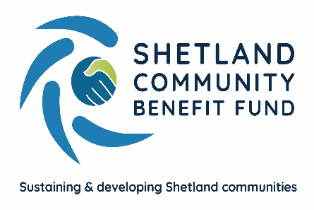
SCBF Directors Meeting

13th July 2022 at 1800

Market House Conference Room

Present

Chris Bunyan, Aileen Brown, John Parry, David Cooper, Colin Clark, Karen Hannay, Alistair Christie-Henry, Jim Anderson, Angela Sutherland, Neville Martin and Jim Milne

In Attendance

Eleanor Gear, Administration Officer

1. Apologies

Robin Black, John Dally, James Garrick and Jamie Macbeath

2. New declarations of interests

None.

3. New Directors/Observers

None. CB welcomed Jim Milne who was attending for the first time and gave the advice of “ask questions” either tonight or later via email. He also hoped Jim enjoys his time with SCBF. Eleanor to send him director’s Handbook.

4. Minutes of 8th June 2022

Proposed by Alistair Christie-Henry, seconded by John Parry. Agreed.

Matters Arising and not covered by the agenda

None

5. Audit and Governance group

(a) Expenses
The last directors meeting decided that as SCBF move to hybrid meetings, an expenses policy should be created to ensure directors are recompensed when attending meetings in person. Aileen Brown drafted a simple policy which was circulated prior to the meeting. It was agreed that prior approval would be required for any purchases made by directors and for corporate hospitality. This approval would be from the chair, officers or given during directors’ meetings. Receipts must also be supplied alongside claims forms. Mileage can be claimed at 45p per mile and will be tracked to the current rate, buses and ferries can be reclaimed at cost. A cap of £50 will be made on Taxi fares and these would only be reclaimable where a more cost effective alternative hasn’t been available. Policy adopted to include these minor amendments and will be available on the SCBF website once published.
6. Administration

Nothing to report.
7. Financial Report

(a) Report on 2022-23 income and expenditure - circulated

The main change on the income and expenditure report is the movement of funds between the savings accounts and business current account. Funds are moved as required to meet SCBF’s financial obligations. Finance report noted.

8. Legal and Accountancy Advice

Noting to report.
9. Viking Energy

Nothing to report

10. Business Plan Sub-Group

(a) Consultation update – paper circulated

CB, Colin Clark, John Dally (via Zoom) and Eleanor Gear met with Eddy from IBP on Monday 4th July. The main note from the report is that the Business Plan Subgroup has agreed that IBP will distribute the main consultation survey to every household in Shetland. Angela Sutherland queried the cost of this and has agreed to supply a second quote. Jim Anderson asked if there will be any publicity prior to households receiving the survey to make them aware, CB confirmed there would be. Report noted.

11. AGS

(a) Report on applications received – circulated

Report noted.

(b) AGS Review proposed amendments – paper circulated

Part 1 of the paper discussed the results of the recent AGS survey. Applicants and community councils are happy with the AGS and, their contact with the Administration Officer.

The report was then discussed. The main changes are to create separate FAQ’s for applicants and community councils which will provide further clarity on the points raised during the survey. Tighten timescales for responding to applications when no communication is received. Restrict the word count on applications which will encourage applicants to be clear on their project. Tighten up the wording within the guidelines on the rules on reapplying and applications to multiple community councils.

An email will be sent to community councils advising of the changes to the AGS and the reasons for them.

Report and changes (with minor amendments) agreed. Draft documents will be circulated for the next meeting.

12. Shetland Aerogenerators Community Benefit Fund

Nothing to report

13. Other commercial renewable energy scheme

CB, Colin Clark and John Parry are meeting with John Smith (Director of Infrastructure, SIC) to discuss the ORION project on Thursday 14th July. CB also met with ESB to discuss community benefit and Colin Clark advised that PEEL is keen to speak to SCBF when they are in Shetland at the end of the summer.

During a recent ASCC meeting, CB was invited to attend a Yell community council meeting, date to be confirmed.

The SCBF principle has always been that a proportion of any community benefit agreements should be shared across the islands.

14. Any other business

Date of next meeting – 10th August 2022 at 1800

Meeting closed at 19:10 with nothing further to discuss.

