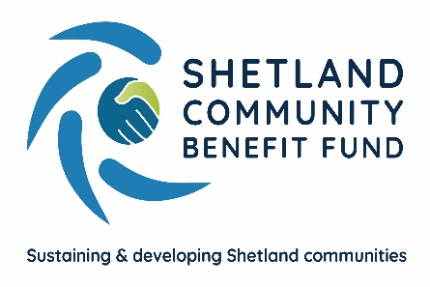
SCBF Directors Meeting

10th July 2024 at 1800

Via Zoom

Present: Chris Bunyan, Alistair Christie-Henry, Colin Clark, Aileen Brown, Jim Anderson, David Cooper, Jamie MacBeath and John Parry
In Attendance: Eleanor Gear, Fund Manager and Emma McKay, Administration Officer.
1. Apologies
None
2. New declarations of interests
None
3. New Directors/Observers
None
4. Minutes 12th June 2024
Proposed by Alistair Christie-Henry, seconded by Jim Anderson. Agreed.
Matters arising and not covered by Agenda
None
5. Audit and Governance Group
Nothing to report.
6. Administration
(a) nothing to report.
7. Financial Report
(a) Report on 2024-25 income and expenditure
Report noted.

8. Legal and Accountancy Advice

RSM have updated SCBF regarding status of Corporation Tax review. RSM have concluded that SCBF do not amount to taxable trading and therefore only liable for corporation tax on any bank interest. RSM are to contact HMRC for confirmation.

9. Viking Energy

None
10 Fund Management Group
The Viking Community Fund leaflets have been printed and are due to be distributed via Royal Mail in the 1st two weeks of August to al Shetland households.
NB Communications have completed the 1st live version of the new website. This is scheduled to go live to the public around the second half of August.
(a) Attendance at local shows - discussion was had as to who was attending each show. Pull-up banners will be on display and there will be leaflets for distribution. Information regarding the AGS in each community area hosting a show are being prepared for directors to share with visitors to the stand.
11 AGS
(a) Application Summary Report – (circulated)
Report noted.
12 Shetland Aerogenerators Community Benefit Fund
Nothing new to report
13 Other Commercial Renewable Energy Schemes
The sub-group continues to maintain contact regarding proposed local developments.
14 Any other business
Jamie Macbeath informed directors that Sandness and Walls Community Council had discussed the Business Plan and felt that increased funding was necessary to make a real difference on major issues such as increased housing or improved broadband. The Fund Manager confirmed that funding allocations in the Plan could be changed depending on the nature of the initial projects. On issues such as housing, SCBF would look to help community groups develop projects and access additional funding, but not to build houses itself. SCBF would look to work in partnership with other funders wherever possible and funding for a project might be spread over a number of years.

Meeting closed at 1832 hours
Date of next meeting will be Wednesday 14th August 2024.

