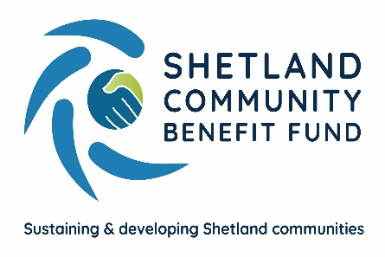
Safeguarding Policy for Children and
Vulnerable Adults

The purpose and scope of this policy statement
Shetland Community Benefit Fund’s strategic objective is to help "sustain and develop Shetland's communities.” SCBF administers community benefit funding and will distribute it by grants, loans or investments to community councils and community groups, businesses and others who help sustain and develop Shetland’s communities.
The purpose of this policy statement is:
- to protect from harm vulnerable people, children and young people who might benefit directly or indirectly from Shetland Community Benefit Fund’s support.
- to provide directors, staff, community councils and all applicants for support, as well as vulnerable people, children and young people and their families, with the overarching principles that guide our approach to safeguarding and child protection.
This policy must be accepted by anyone working on behalf of Shetland Community Benefit Fund, staff, directors, any agency staff and also to community councils participating the SCBF support schemes and all applicants for support.
Legal framework
This policy has been drawn up on the basis of legislation, policy and guidance that seeks to protect vulnerable people and children in Scotland.
Supporting documents
This policy statement should be read alongside any other related documents and procedures.
We believe that:
- Vulnerable people, children and young people should never experience abuse of any kind
- We all have a responsibility to promote the welfare of all vulnerable adults, children and young people, to keep them safe and to practise in a way that protects them.
We recognise that:
- The welfare of vulnerable people and children is paramount in all the work we do and in all the decisions we take all people, regardless of age, disability, gender reassignment, race, religion or belief, sex, or sexual orientation have an equal right to protection from all types of harm or abuse.
- Some people are additionally vulnerable because of the impact of previous experiences, their level of dependency, communication needs or other issues.
- Working in partnership with vulnerable people, children, young people, their parents, carers and other agencies is essential in promoting people’s welfare.
We will seek to keep vulnerable people, children and young people safe by:
- Valuing, listening to and respecting them.
- Appointing a board member for safeguarding.
- Adopting child protection and safeguarding best practice through our policies, procedures and code of conduct for staff and volunteers
- Developing and implementing an effective online safety policy and related procedures.
- Providing effective management for staff, directors and any agency staff through supervision, support, training and quality assurance measures so that all know about and follow our policies, procedures and behavior codes confidently and competently.
- Recruiting and selecting staff safely, ensuring all necessary checks are made.
- Recording, storing and using information professionally and securely, in line with data protection legislation and guidance and SCBF policies.
- When appropriate sharing information about safeguarding and good practice with those seeking support from SCBF and vulnerable people, children and their families via leaflets, posters, group work and one-to-one discussions.
- Making sure that vulnerable people, children, young people and their families know where to go for help if they have a concern.
- Using our safeguarding and child protection procedures to share concerns and relevant information with agencies who need to know, and involving vulnerable people, children, young people, parents, families and carers appropriately.
- Using our procedures to manage any allegations against staff, directors, community councils and applicants appropriately.
- Creating and maintaining an anti-bullying environment and ensuring that we have a policy and procedure to help us deal effectively with any bullying that does arise.
- Ensuring that we have effective complaints and whistleblowing measures in place.
- Ensuring that we provide a safe physical environment for our vulnerable people, children, young people, staff and volunteers, by applying health and safety measures in accordance with the law and regulatory guidance.
- Building a safeguarding culture where staff, directors, community councils, applicants and volunteers, vulnerable people, children, young people and their families, treat each other with respect and are comfortable about sharing concerns.

Contact details
Board Member lead for safeguarding and child protection is Gordon Thomson.
Email: gthamar99@gmail.com Telephone: 07554 970 862

SCBF is committed to reviewing our policy and good practice annually.

This policy was last reviewed on: XXXXXXXXXXXXX January 2021

Signed: …………Gordon Thomson……………………………………………………………

Date: …………………………1/2/2021………………………………………………

