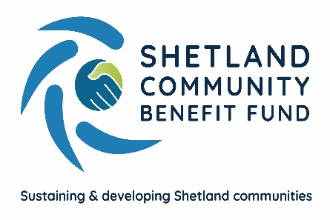

Advanced Grant Scheme
Tier 1 grant application (£50-500)

SCBF is an independent co-operative formed by Shetland's 18 community councils. SCBF has agreements with Viking Energy Wind Farm LLP to run the Viking Community Fund. The grant scheme runs while the windfarm is being built and is only open to projects supported by your local community council.

The Advanced Grant Scheme sets annual budgets for each community council and has two tiers - Tier One grants for projects of £50 up to £500 and Tier Two for projects over £500.

How does the Tier 1 grant scheme work?

Applying is designed to be easy and quick. All Tier 1 grant applications must be sent to SCBF who will verify that the application meets the scheme's objectives before passing details of your project, with personal contact information removed, to your local community council who will decide whether or not to support your project.

Please ensure that you send a recent bank statement, or verified accounts, with your application.

Tier 1 grants can be for an existing project or to develop a new idea. To find out more about the Tier 1 grant process please read the guidelines on the SCBF website. The guidelines also tell you what can and cannot be supported. You should be given a decision within eight weeks of SCBF receiving your application.

Who can apply for a Tier 1 grant?

Applications for Tier 1 grants can be accepted from any charity or group – including those which do not have a written constitution or set of rules – community councils and individuals but not for personal gain. Only one successful application can be made every 12 months.

For more information either email ags@scbf.org.uk or call 07538 417 175

How to apply?
Return your completed application form and any supporting documents to: ags@scbf.org.uk or post to Shetland Community Benefit Fund, AGS Application, Market House, 14 Market Street, Lerwick ZE1 0JP

Tier 1 Grant Application Form
Name
I am applying on behalf of: | Charity Individual Group
Contact Name and address with postcode
Telephone number
Contact email
Is this a new or existing project?

Please describe the project you are looking for funding for?
Suggested word limit 150 words
Explain how the project will meet the scheme's objectives:
• Sustain and Develop the local community
• enhance quality of life for local residents
• encourage community activity
Suggested word limit 150 words
How much money are you applying for?
Is there any information in the application you would like kept confidential? If so, please give brief details | Yes No
Have you attached a recent bank statement and bank account details. | Yes No

Which community council are you applying to for support?
Click HERE and use arrow to select community council

I have read and accept the SCBF's guidelines and policies for child protection and equality.

Signed: ............................................................... Date: .................................

GDPR
Personal Data collected through this application will be used for the purposes of administering your grant and, if successful, it may also be used to promote the SCBF grant scheme. Further details on how we will use your Personal Data, who we share it with and your rights under GDPR can be found in our Privacy Statement
--------------------------------------------------------------------------------------------------------------------------------------
For SCBF Use Only: Reference___________ Date Received: ______________

Document issue date – January 2021
Document review date – January 2022

