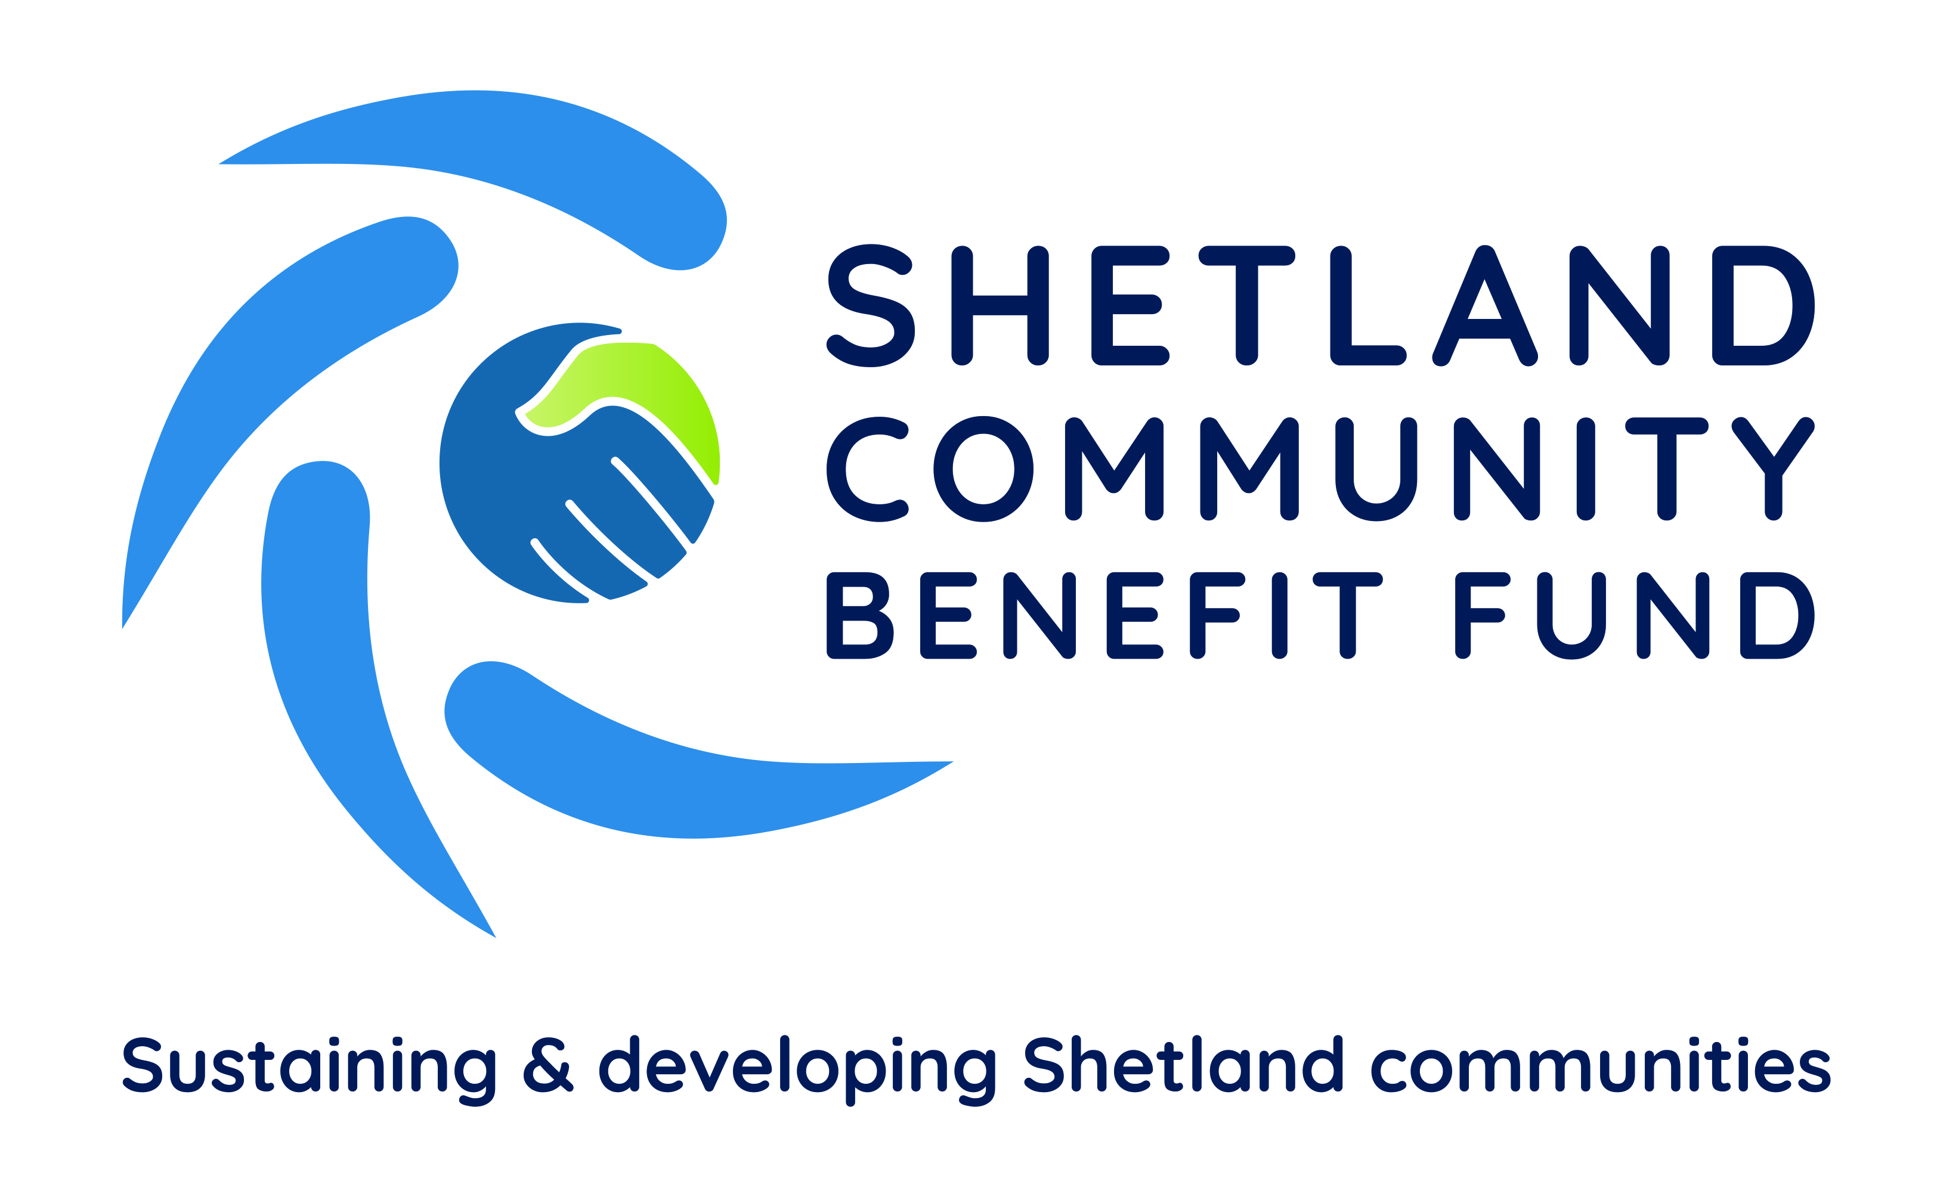

Issued Friday 18th June 2021

Closing date for receipt of tenders 7th August 2021
INVITATION TO TENDER AND SPECFICITION OF SERVICES TO DEVELOP A BUSINESS PLAN
Introduction

Shetland Community Benefit Fund Ltd is a non-charitable Society for the Benefit of the Community. It was established by the Association of Shetland Community Councils as an independent body to manage community benefit agreements with commercial renewable energy developers in the islands. Each of Shetland's 18 community councils nominate a director of SCBF who sits on the management committee.

SCBF has signed a Heads of Terms with Viking Energy Wind Farm LLP (VEWF) and its major shareholder, SSE Renewables, setting out the framework for two legal agreements which will govern the payments from the Viking Community Fund (VCF) which will be administered and managed by SCBF. The HoT allows SCBF to provide grant aid, make investments, and loans.

The first Minute of Agreement was signed in 2020 and provides for a payment of £400,000 a year from the VCF to SCBF until 2024 or when the development becomes operational. The funds are to be used to operate a grant scheme for projects that are supported by one of the islands' 18 community councils and for SCBF to administer the scheme and to develop its long term SCBF Business Plan for the VCF.

The Business Plan must be approved by VEWF before the second Minute of Agreement can be signed. This will release VCF payment of approximately £2,215,000 a year, index-linked, for the lifespan of the development, currently estimated to be 25 years. This will be the largest onshore community benefit scheme in the UK

See the SCBF website for further information

It is desirable that the successful consultant(s) will use Shetland-based resources and suppliers for goods and services, where possible.

Brief overview of distinctive Shetland features

There are a number of distinctive socio-economic features regarding Shetland.

- Its location in the North Sea and distance from mainland UK
- A declining and aging population
- Despite its apparent wealth there is considerable poverty and hardship in the islands, particularly fuel poverty and social isolation
- The income from the oil and gas terminals in the islands
- The Crown Estate grant scheme
- The Shetland Charitable Trust, which helps support the recreation, arts and amenity trusts and care homes for the elderly

The scope of work
SCBF is seeking to appoint an independent consultant(s) with relevant expertise to design and facilitate a community consultation process and produce a Business Plan from the findings of that process. The work will involve initial desk top research, a thorough community consultation, and the drafting of the SCBF Business Plan.
The selected consultant(s) will:
- Work with SCBF and SSE Renewables to identify the methodology for carrying out the project, with particular regard to any health restrictions that may apply during the scope of work and the geographical nature of the Shetland Islands.
- Undertake relevant desktop research in order to identify key socio-economic information about the area.
- Undertake a comprehensive community consultation to establish the community’s aspirations for the Viking Community Fund and its priorities and strategic objectives for sustaining and developing the islands' communities over the period 2024-2030;
- Identify funding programmes to support these objectives which complement any existing financial support streams
- Identify new and imaginative ways of supporting these objectives
- Prepare a draft SCBF Business Plan, discuss the findings and any proposed revisions with SCBF
- Carry out a consultation on the final draft SCBF Business Plan and, in discussion with SCBF, prepare a final Business Plan for presentation to VEWF and SSE Renewables.
The community engagement/consultation must be comprehensive and inclusive, engaging all sections of the community and relevant stakeholders in a process of meaningful discussion and decision-making around key themes and priorities.

You must ensure Shetland-wide as well as local community needs are considered within the process. You will include in your process a review of the Shetland Partnership Plan, and any other relevant plans from statutory bodies, such as Highlands and Islands Enterprise, industry-specific organisations, local charitable trusts and any local community development plans.

This work will demonstrate good practice in line with the National Standards for Community Engagement, be inclusive and transparent, and as far as possible seek to enhance the engagement of local people in contributing to activity that advances the Business Plan. The engagement process will also identify a set of core values and strategic objectives to guide implementation of the Business Plan.

The process may include, but is not restricted to:*

- A review of current services and facilities, including Local Development Plans
- A widely distributed questionnaire survey
- Marketing campaign and engagement through local media and online
- Workshops or focus groups with target groups
- Collate and analyse the data, identifying key findings
- A public event feeding back and seeking to confirm / refine the findings.

* Any health restrictions that apply in Shetland, Scotland or other parts of the UK during this process may affect the methodology used.

As a result of the above work, an initial Business Plan be presented in draft for discussion by a working group and other local stakeholders. The draft will be considered by SCBF and amended based on feedback received.

Following this work, using the support processes available to SCBF under its proposed agreements with VEWF and SSE Renewables, you will

- identify funding schemes to support these objectives which complement any existing financial support streams

- Identify new and imaginative ways of supporting these objectives
The Business Plan will include relevant graphic and visual information and be written in plain English. This will include:

- A short profile of the community presented in an accessible and succinct format and highlighting key socio-economic information;
- An audit of current activity, support and services provided by community groups/ organisations, public authorities, local trusts and others.
- A community vision for the area and associated underpinning values or principles to guide implementation of the plan
- Identification of key themes or outcomes and related (realistic) priority activity over lifetime of the business Plan (2024-2030). In some instances, the plan may detail particular projects.
- A thorough explanation of the methodology behind the consultation including materials produced and data collected
- An outline of how the plan can be monitored and reviewed
- An Executive Summary for wider dissemination.

Project Timetable

SCBF anticipates that the project will start in Q1 2022 with initial discussions with SCBF and SSE Renewables and with preparation for the consultation process starting Q2 2022 and the process itself during Q3-4 2022. The contract work should be completed by Q3 2023. This timetable may be varied depending on windfarm construction progress and discussions between SCBF and SSE Renewables.

Tender circulated to prospective consultants | Week beginning 21/06/21
Closing date for proposals | Friday 07/08/21
Applications considered for short listing | 08/08/21 to 21/08/21
Interviews of short listed applicants | Week beginning 06/09/21
Decision | By 30/09/21
Work starts; inception/planning meeting; begin desk-top research | Q2 2022
Community consultation incl. feedback | Q3 2022
Draft Community Action Plan submitted | Q1 2023
Comments and revisions incorporated | Q2 2023
Final Community Action Plan signed off | Q3 2023

Guidance on tender submissions

Submissions should include an outline of your proposed methodology and approach to both the consultation, the development of the Business Plan and identifying and designing suitable funding streams.
The submission should also include short CVs for all consultants involved and budget details, including an estimate of expenses.
Please try to keep your proposal to four sides of A4. Please also include references from two communities you have worked with recently (past 3 years) to conduct a similar exercise.

Skills and experience

The successful tender will demonstrate:

- Significant experience of working with communities, including good interpersonal, facilitation and engagement skills.
- Knowledge and skills in participatory approaches to community action planning.
- Good writing and presentation skills, with an accessible style of communication.
- The relevant skills of each member of the project team and which tasks they will be carrying out

Methodology

- Demonstrate in detail how the scope of works above will be delivered
- Set out a project plan demonstrating how the work will be phased.

Price

- Provide detailed costing for all activities in the scope of works. Project costing should be clearly broken down by project tasks.
- Demonstrate best value for money.
- Include all materials, travel and subsistence, and VAT (where applicable).

Application process

Please send your proposal by email to admin@scbf.org.uk by Friday 7th August 2021 or post to:

Shetland Community Benefit Fund,
ITT Tender,
14 Market Street,
Lerwick, Shetland ZE1 0JP

to arrive no later than Friday 7th August 2021
If you would like any further information please contact SCBF chair, Chris Bunyan -

Phone - 01595820336
email - shetlandcommunitybenefitfund@outlook.com.

