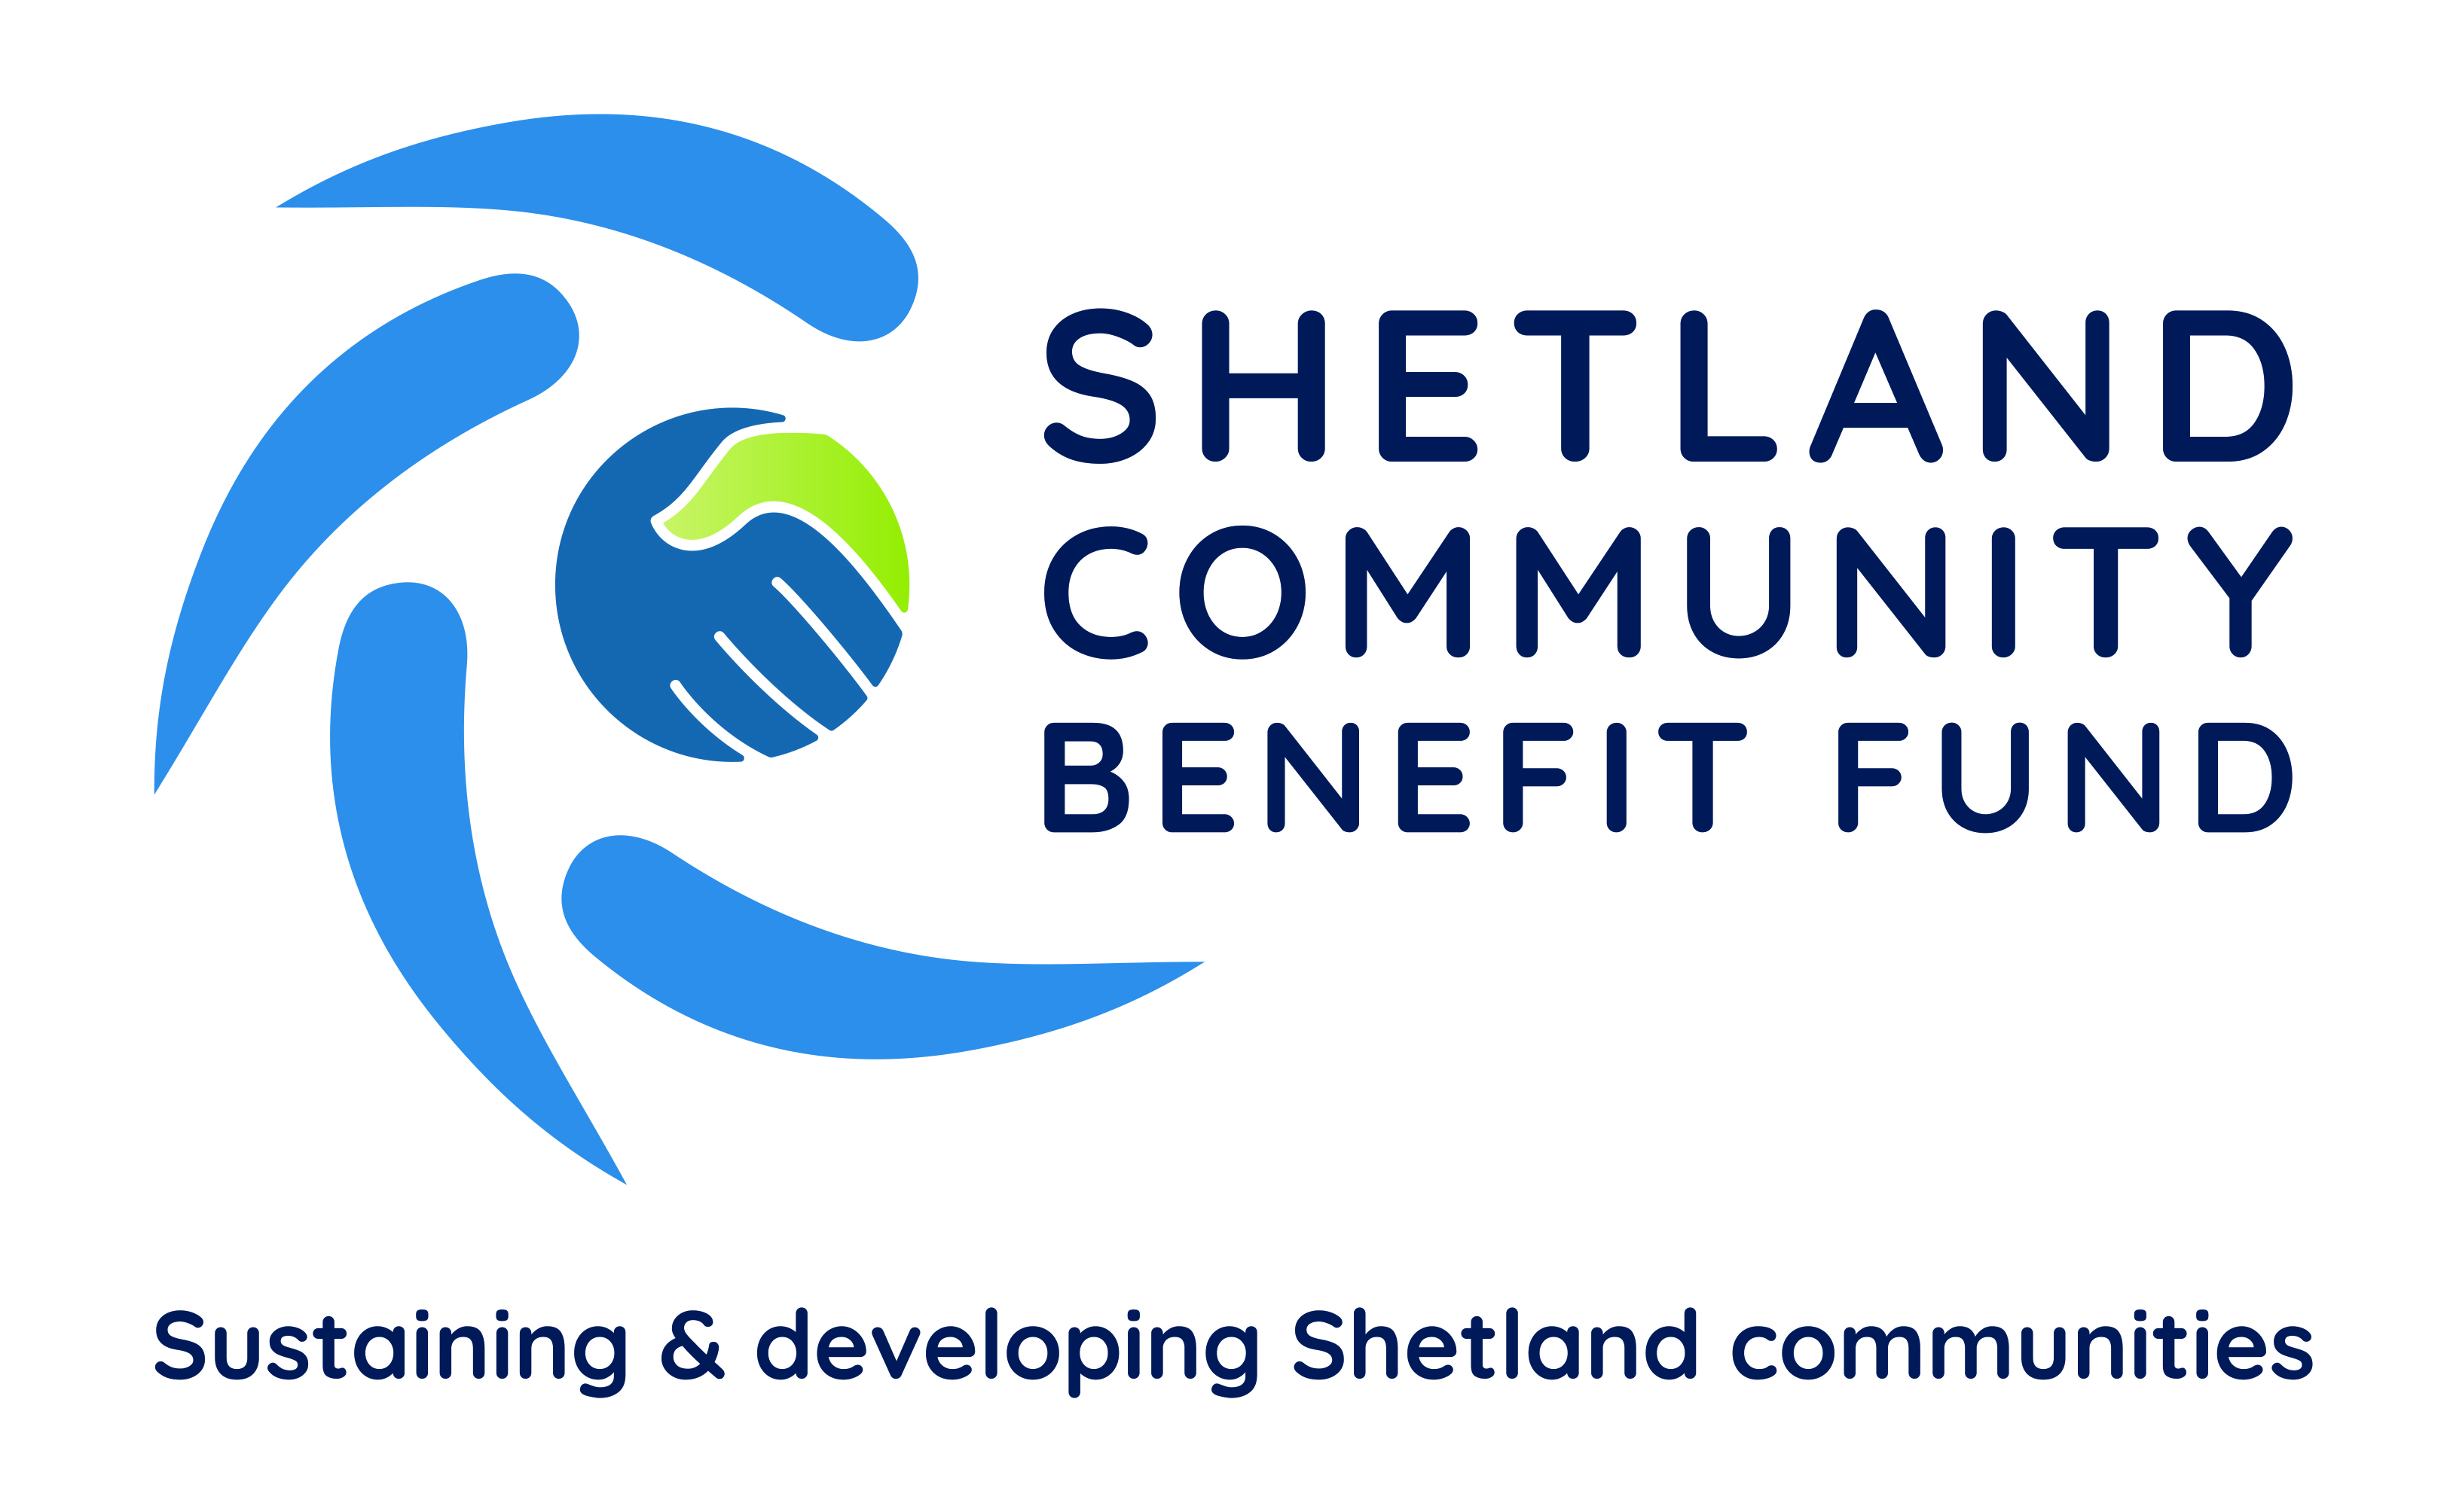
Grants from Unst to Fair Isle
Grants for projects from Fair Isle to Unst have been awarded in May by Shetland Community Benefit Fund and the Viking Community Fund.
Fair Isle Development Company is to receive £1,500 towards buying a fuel bowser and trailer which will allow fuel deliveries around the island.
In Unst two projects have been supported - £500 is going to the Unst Partnership for its community skip scheme while the Wild Skies Shetland charity is also getting £500 towards the cost of a short film about 'Unst the Asteroid'.
On Foula the island's electricity trust is to receive £2,055 for a survey to collect evidence that the island's wind turbines can be left running during the bird breeding season without impacting on the protected SSSI species on Foula.
Nearly £11,000 will be used by the Lunnasting Public Hall to replace two fire doors and repair exterior blockwork. A spokesman for the hall committee thanked SCBF for the award. "This will enable us to reopen the hall post lockdown and bring the community back together. Thank you."
Other grants award in the past month include £3,000 to the Papa Stour History and Community Group towards its ambitious plans to develop the island's kirk; over £7,400 to replace the fire alarm system at the Voxter Centre; and £500 for outdoor play equipment and clothing for the South Mainland Kindergym.
Full details of the projects supported by grant scheme are available at www.scbf.org.uk/projects
END
31st May 2021

Further information from Chris Bunyan, SCBF Chair 01595820336 or 07880590331

