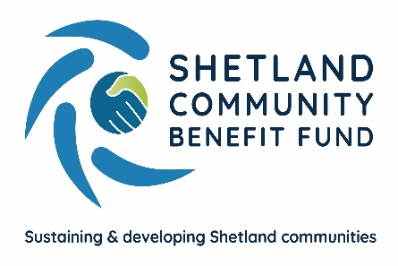

Successful First Year of Grant Scheme

Over 120 community groups have applied for nearly £300,000 from the Viking Community Fund, operated by Shetland Community Benefit Fund in the first year of the current grant aid scheme. The funding has helped secure projects with a total value of nearly £1.5m.
Recent schemes that have been approved include nearly £10,000 for improvements to the South Mainland Up-Helly-Aa galley shed, £5,000 for improvements at the Symbister Public Hall and a £10,000 grant for Fetlar Community Association’s new website.
Approved schemes from Parent Councils include £7,000 for a new sheltered area for the Urafirth school and £4,600 for a new poly tunnel cover at the Whalsay primary school.
The Unst junior badminton, football and netball associations have all received grant aid as well as Sandwick and Scalloway boating clubs.
Community benefit fund chair, Chris Bunyan, said the first year of the advanced grant scheme, which runs during the construction of the Viking wind farm, had been very successful – but many areas still have funds available for projects. “There’s a number of areas with substantial funds waiting for groups to come forward with suitable projects. For example, Delting has already given out £51,000 in grants and still has £49,000 available for projects that qualify and are approved by the community council, and will have another £50,000 in September”. He urged local groups to use the Viking Community Fund either to finance schemes or help secure funding from other sources.
“The scheme is simple to use and it’s easy to apply”, Mr Bunyan said. “There are few restrictions on who can apply or what funds can be used for. Please see our website, scbf.org.uk, for all the details”.

ENDS

Further information from Chris Bunyan 01595820336 or 07880590331

