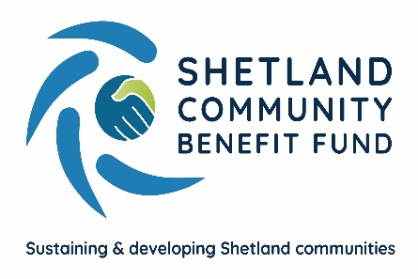

Viking Community Fund, Advance Grant Scheme – Annual Report

Foreword

I am delighted that at long last the Shetland Community Benefit Fund has been able to launch the Advanced Grant Scheme using the Viking Community Fund. It is a unique scheme that required a lot of work and co-operation with Shetland local community councils.
SCBF’s directors are rightly proud of the many projects the scheme has supported and the difference these have made to local communities. Often it is the small grant that can have the biggest effect.
SCBF has learnt a lot in this first year of the grant scheme and we are conducting a full review to see if it can be improved. We are lucky to have a skilled administration officer in Eleanor Gear who has run the scheme efficiently and dealt with all the challenges such a new scheme is bound to throw up.
While running the AGS, we have been preparing the groundwork needed for the main SCBF funding from the Viking Community Fund of about £2.2m a year which is expected to start in the summer of 2024. The AGS has provided valuable experience and we are now about to start on a two-year project to consult the local community and stakeholders on the priorities for using the main core funds. This will be a major task and will run alongside the Advanced Grant Scheme.
If I can have one hope for the grant scheme, it is that local groups and enterprises will come forward with new and imaginative projects in the remaining years the grant scheme will operate.
Chris Bunyan
Chair, SCBF

The Advance Grant Scheme (AGS)
The Viking Community Fund’s Advanced Grant Scheme runs each year from 1st September to 31st August with each community council receiving their annual round of funding on the 1st September. This Annual report detailing funded projects and awarded grants runs from 14th February 2021, when the scheme was formally launched, to 31st August 2021.
Each year of the construction phase for the Viking Energy Wind Farm £340,000 is made available annually to Shetland Community Benefit Fund Ltd from the Viking Community Fund. This is used for the grant scheme for projects supported by Shetland’s 18 community councils. The four community councils which have a Viking turbine in their area - Delting, Tingwall Whiteness and Weisdale, Nesting and Lunnasting, and Sandsting and Aithsting - have £50,000 available annually for projects while the other 14 community councils have £10,000 each. A community council is able to defer spending if they know of a future project it wishes to support, and to draw down its allocation from future years to help finance a project.
Committed and Available AGS funding 2020/21

From the Viking Community Fund’s Advance Grant Schemes total funding pot of £400,000, SCBF allocate a maximum of £60,000 to administration of the scheme leaving a balance of £340,000 split between Shetland’s 18 community councils as detailed above. Total grant funding allocated for the 2020/21 AGS year was £200,937.35 leaving a total of £139,062.65 carried over into the 2021/22 AGS year.

Tier 1 Grant Applications

Tier 1 grants of £50 to £500 are to support small projects which might need only a small level of support. This could be for an existing project or to develop a new idea. The application is short and easy to access with only one successful application is allowed annually.
Supported T1 projects

The Viking Community Fund Advance Grant Scheme has supported 16 Tier 1 projects since its launch. Of the 16 supported projects, one applicant, Shetland Classic Motor Show applied to all 18 community councils receiving grant funding from 12 of them up to 31st August and the Royal Voluntary Service applied to 9 community councils and secured funding from them all.

Tier 1 funding total – £14,820.09

Details of T1 projects awarded funding between 14th February 2021 and 31st August 2021

Unst Partnership Ltd  Funding towards subsidising the community skip scheme due to shortfall in overall annual cost. | £500.00
Royal Voluntary Service – Burra & Trondra, Gulberwick, Quarff & Cunningsburgh, Lerwick and Whalsay  Funding to provide a social activity for clients such as a bus run, provision of transport to go out for a meal or a visit to another social club. | £500.00 from each area
Royal Voluntary Service – Northmaven and Sandsting & Aithsting  Funding to provide a social activity for clients such as a bus run, provision of transport to go out for a meal or a visit to another social club. | £200.00 from each area
Royal Voluntary Service – Sandwick and Sandness & Walls  Funding to provide a social activity for clients such as a bus run, provision of transport to go out for a meal or a visit to another social club. | £400.00 from each area
Bressay Public Hall  Funding for purchase of a new freezer. | £272.49
The Outpost  Funding towards constructing an accessible bird aviary. | £500.00
South Mainland Kindergym  Funding towards outdoor play equipment, waterproof clothing, and baby equipment. | £500.00
Burravoe Primary School Parent Council  Funding to purchase topsoil and compost for the new polycrub. | £500.00
Sandness Community Development Group  Funding to purchase spare parts and paints to preserve the community phonebox under the BT adopt a kiosk scheme. | £500.00
Wild Skies Shetland  Funding towards production of a short film about Unst-the-asteroid. | £500.00
Sandness History Group  Funding towards purchase and restoration of old photographs to include in a book on Sandness history. | £500.00
Gulberwick, Quarff and Cunningsburgh Community Council  Funding towards a project to reduce dog fouling problem, posters, poo bags etc. | £400.00
Volunteer Group led by an individual for Fernlea Care Centre  Funding to purchase aggregate and paving slabs to improve the care centre garden. | £496.00
Cunningsburgh Under 5’s  Hold a discounted Aa Fired Up session decorating Christmas baubles | £490.00
Classic Motor Show – Bressay, Delting, Dunrossness, Gulberwick, Quarff & Cunningsburgh, Lerwick, Sandness & Walls, Sandsting & Aithsting, Sandwick, Tingwall, Whiteness & Weisdale, Unst and Whalsay  Funding towards the cost of staging the biennial Shetland Classic Motor Show & Tours in 2022. | £400.00 from each area listed
Classic Motor Show – Yell  Funding towards the cost of staging the biennial Shetland Classic Motor Show & Tours in 2022. | £200.00
South Mainland Community Association  Funding to purchase picnic tables. | £500.00
Bressay Community Council  Funding to purchase two lockable notice boards for Bressay and Lerwick ferry terminals. | £361.60
South Mainland Amateur Swimming Club – Dunrossness and Gulberwick, Quarff and Cunningsburgh  Funding to deliver a COVID recovery wellbeing package to members. | £500.00 from each area

Tier 1 projects need to support at least one of the following priorities,

- Sustain and develop the local community
- Enhance quality of life for local residents
- Encourage community activity

The following chart visually details which areas the fund has been supporting so far.

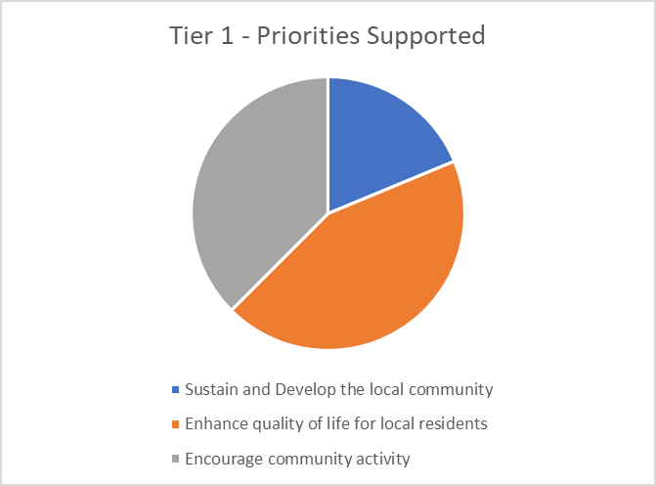

Tier 2 Grant Applications – over £500

Tier 2 grants over £500 are to support projects which need a larger investment. These applications are from constituted groups with a bank account and up to date accounts. Projects must support the aims of the AGS and should be sustainable without dependence on continued funding from the AGS.

Supported Tier 2 projects

A total of 23 applications were awarded grant funding. Of those, 1 applicant applied to all 18 community councils. Dogs Against Drugs secured funding from 16 of the 18 community councils up to 31st August 2021.

Tier 2 funding total - £186,117.26

Details of T2 projects awarded grant funding from 14th February 2021 to 31st August 2021

Mossbank Public Hall  Funding to purchase a dishwasher and glass washer. | £4,608.00
South Nesting Hall  Funding towards the replacement of the hall's accessibility access ramp. | £1,900.00
Voe Public Hall  Funding towards improvements to kitchen facilities including a small extension. | £30,000.00
North Staney Hill Community Association  Funding towards repairs and upgrading of Staney Hill hall including painting, tiling, toilet grab rails. | £4,500.00
Scalloway Community Development Company  Funding to help construct the necessary infrastructure of a new caravan site, and more specifically to enable the provision of high quality facilities in the amenity building | £16,000.00
Sandwick Social and Economic Development  Funding to purchase a new coffee machine including delivery, training and future maintenance (included in package). | £4,940.00
South Nesting Boating Club  Funding towards land purchase to build a new marina. | £40,000.00
Cullivoe Up Helly Aa Committee  Funding towards upgrades to the Cullivoe galley shed. (Rewiring and insulation - phases 4 and 5 of project.) | £5,000.00
Lunnasting Public Hall  Funding towards replacing the hall's 2 fire doors and repairing exterior blockwork. | £10,944.00
Brough Lodge Trust  Funding towards the design, sketch and 3D modelling of Brough Lodge. | £10,000.00
Voxter Centre Trust  Funding towards the replacement of the fire alarm system at Voxter House. | £7,409.86
Papa Stour History and Community Group  Funding towards building works for kirk development project. | £3,000.00
Fair Isle Development Company  Funding towards the purchase of a bowser and trailer (for community fuel deliveries). | £1,500.00
Foula Electricity Trust  Funding to carry out evidence collection that leaving wind turbines on during bird breeding season will not impact the SSSI target species present on Foula. | £2,055.00
Northmavine Community Development Company (NCDC)  Funding to carry out a structural condition survey on the old Urafirth School and school house with the view of potentially purchasing the buildings | £1,140.00
Cullivoe Primary Parent Council  Funding for a school garden development project. | £3,800.00
Whiteness Primary School Parent Council  Funding to purchase Outlast Nursery classic set (outdoor block play resource) for outdoor play area. | £2,208.40
Burra and Trondra Community Council  Funding towards repairs to the War Memorial, Bridge End, Burra. | £2,520.00
Bridge End Community Hall  Funding towards disabled toilet renovations in hall. | £4,462.00
Sandwick Youth and Community Centre  Funding to carry out a structural survey on the community centre. | £1,500.00
Dogs Against Drugs – Bressay, Burra & Trondra, Dunrossness, Gulberwick, Quarff and Cunningsburgh, Lerwick, Sandness & Walls, Sandwick, Scalloway, Unst and Whalsay  Funding to cover core costs of organisation and delivery of education and awareness raising programmes to children, young people and adults | £1,000.00 from each area
Dogs Against Drugs – Delting, Sandsting & Aithsting and Tingwall, Whiteness & Weisdale  Funding to cover core costs of organisation and delivery of education and awareness raising programmes to children, young people and adults | £5,000.00 from each area
Dogs Against Drugs – Nesting and Lunnasting  Funding to cover core costs of organisation and delivery of education and awareness raising programmes to children, young people and adults | £2,500.00
Dogs Against Drugs – Northmaven and Yell  Funding to cover core costs of organisation and delivery of education and awareness raising programmes to children, young people and adults | £500.00 from each area
Hillswick Public Hall  Funding to purchase a PA system for the hall. | £1,250.00
Quarff War Memorial Group  Funding towards repositioning of the Quarff war memorial. | £2,380.00

Tier 2 projects must meet a minimum of one of the following nine AGS priorities.

- Reducing poverty and social deprivation, particularly child poverty
- Promoting social inclusion and mental wellbeing
- Promoting improved transport within and between communities that would add value to a wider Shetland Community
- Energy improvement schemes - energy reduction, fuel poverty, local renewable schemes
- Developing or improving community assets
- Supporting the local community's economy by retaining essential skills through training and apprenticeships
- Developing or improving local heritage, cultural, sport, and arts facilities or activities
- Improving telecommunications within the local community
- Protecting or improving the local environment

The following pie chart visually demonstrates which priorities the fund has been supporting so far.
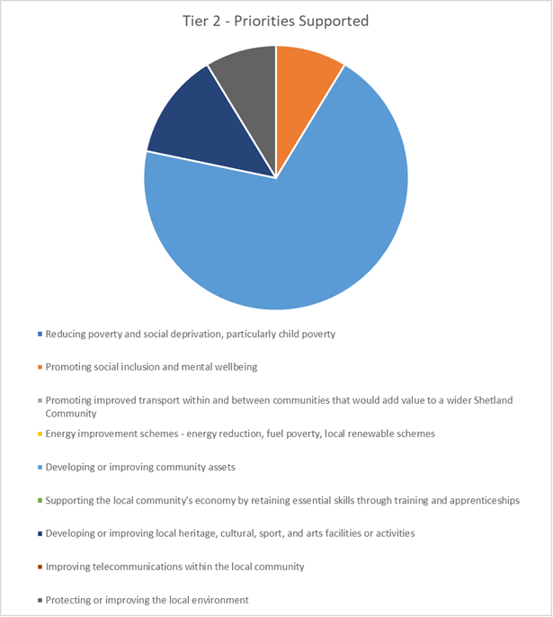

Breakdown of expenditure for each community council area 2020/21
Community Council | Funds Committed | Funds Remaining | Tier 2 Grants | Tier 1 Grants
Bressay | £2,034.09 | £7,965.91 | 1 | 3
Burra & Trondra | £8,982.00 | £1,018.00 | 3 | 2
Delting | £47,417.86 | £2,582.14 | 4 | 1
Dunrossness | £4,400.00 | £5,600.00 | 2 | 4
Fetlar | £10,000.00 | £0.00 | 1 | 0
Gulberwick, Quarff & Cunningsburgh | £5,670.00 | £4,330.00 | 2 | 5
Lerwick | £6,400.00 | £3,600.00 | 2 | 2
Nesting & Lunnasting | £52,844.00 | -£2,844.00* | 3 | 0
Northmaven | £3,090.00 | £6,910.00 | 3 | 1
Sandness & Walls | £7,855.00 | £2,145.00 | 3 | 4
Sandsting & Aithsting | £5,600.00 | £44,400.00 | 1 | 2
Sandwick | £9,140.00 | £860.00 | 3 | 2
Scalloway | £10,000.00 | £0.00 | 1 | 0
Skerries | £0.00 | £10,000.00 | 0 | 0
Tingwall, Whiteness & Weisdale | £7,608.40 | £42,391.60 | 2 | 1
Unst | £2,400.00 | £7,600.00 | 1 | 3
Whalsay | £2,396.00 | £7,604.00 | 1 | 3
Yell | £10,000.00 | £0.00 | 3 | 2

*Community councils are permitted to ‘draw down’ funds from future years if they wish to support projects which exceed their AGS allocation of funds. Nesting and Lunnasting community council approved grants in excess of their £50,000 allocation of funds and requested to draw down £2,844 from their 2021/22 AGS allocation.
Three community councils committed their full allocation of funding, two of which towards a single large project. Four areas committed over ¾ of their funds and a further four areas spent over half or almost half of their annual allocation.

