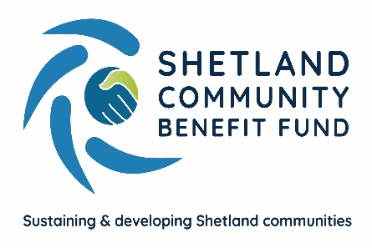
Renewable energy schemes supported by Viking fund

Over £150,000 in grants has been award from the Viking Community Fund so far this year – with about half going to three projects in Sandsting and Aithsting.
The largest grant from the Advanced Grant Scheme, run by the Shetland Community Benefit Fund, is £44,581 awarded to the Skeld Community Hall for a new 6kw wind turbine to replace an old machine that hasn’t worked for a number of years. The new turbine will be installed by local contractors Nordri and the grant covers other associated work, such as new wiring.
The new turbine will allow the hall committee to once again benefit with income from the feed-in tariff that will run until 2031.
Skeld hall secretary Janet Crooks-Jones said they were delighted to receive the grant from the Viking Community Fund to replace and upgrade the Hall's wind turbine. “The new turbine will make heating the hall much more efficient and affordable, helping to make this much-loved hall a warm and welcoming place for the many people on the Westside and across Shetland who visit for our varied programme of events and activities.”

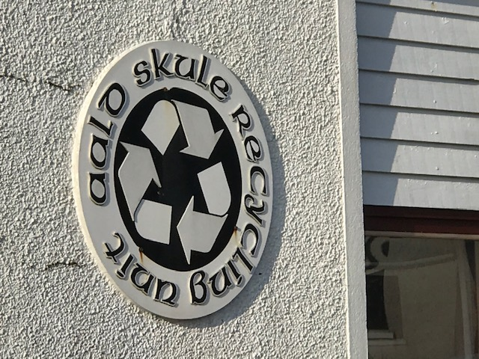
Figure 1The recycling centre in the Aald Skule in Aith will get a grant of £22,287 grant for improvements

A project at Auld Skule Recycling Unit in Aith will see a new air-source heating system together with new doors and windows and the Viking Community Fund is contributing £22,287 towards the total cost.
Also in Aith, the junior high school parent council has received £7,670 to purchase 26 iPads to help pupils access remote learning and other on-line programmes.
The Shetland Cattle Herd Book Society has been awarded £13,225 towards the cost of a major initiative to expand the society’s work. Among the other projects recently awarded by SCBF are £10,000 towards the cost of a new wind turbine at the Isbister Hall on Whalsay, £18,133 for the Shetland Care Attendants Scheme; £10,000 to the Shetland Gymnastics Club; £3,400 to the compass Centre towards building improvements.
Sporting groups in Unst, Sandwick and Dunrossness have also been awarded grants.
A full list of the grants awarded under the scheme and how to apply for a grant are available at www.scbf.org.uk/ags

ENDS
8th May 2022
For further details of any grant please contact SCBF administration officer, Eleanor Gear, on admin@scbf.org.uk, Tel 07538417175 or call the SCBF chair, Chris Bunyan, on 01595820336

