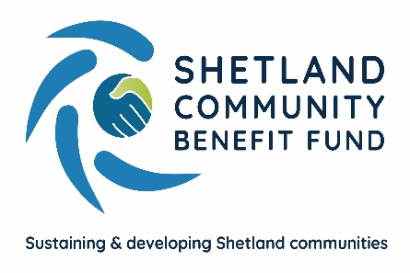

SCBF Advanced Grant Scheme – Appeals Procedure

Shetland Community Benefit Fund aims to provide a clear and transparent application process for the Advance Grant Scheme to ensure applications are dealt with fairly and outcomes are just. We understand however, that the outcome of a grant application may not always be as the applicant hopes. This procedure outlines the course of action available if an applicant wishes to raise an appeal concerning a decision on an application for a grant. There is a separate Complaints Policy for applicants and others who have dealings concerning Shetland Community Benefit Fund. It is available here
Appeals Procedure
If your application is rejected by SCBF as failing to meet our guidelines, or if it is unsuccessful in getting community council support, we will tell you why.
Reasons for an application being rejected by SCBF may include, but not necessarily limited to:
- Ongoing commitment – the project lacks evidence in how it will self-support when funding ends.
- The applicant has already received a grant within the previous 12 months of accepting the grant offer.
- The applicant has already received a grant but failed to provide monitoring and/or feedback information required by SCBF
- The application is for an identical project that has previously secured funding
- Concerns over information provided to SCBF during due diligence checks.

If an application is refused funding by a community council, or only part of the funds applied for have been agreed by a community council the reasons may include, but are not limited to:
- Local need – failure to show how the project supports the local needs of the community.
- Compliance with priorities – the project does not comply with the local aims and objectives of the community council area.
- There is not enough evidence of demand/need for the project.
- Community engagement – there has been little or no community engagement in support of the project.
- The community council allocation is over-subscribed and other applications have been stronger.
Appeals must be made by email to ags@scbf.org.uk within 5 working days of receiving the decision from SCBF. You must have grounds and cannot simply appeal because you do not like the decision. You must provide evidence, such as you consider that SCBF, or the community council has not taken into account all of the information submitted with your application and you believe your application has not been treated fairly.
If your appeal concerns a decision of a community council, on receipt of your appeal, it will be logged and investigated by SCBF’s Administration Officer. SCBF aims to respond within 10 working days of receiving your complaint with a decision. If the decision is upheld, you may make a final appeal in writing to the SCBF officers. Their decision will be final.
If your appeal concerns a decision by SCBF itself, on receipt of your appeal it will be referred to the officers on the SCBF management sub-committee. If you disagree with their decision you may lodge a final appeal, stating your reasons for the appeal, which will be reviewed by three other SCBF directors. Their decision will be final.

Document issue date – June 2022
Document review date – June 2023

