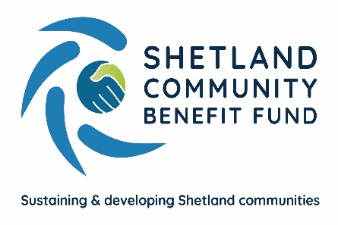
FAQs for Applicants – Advanced Grant Scheme

Q – Can you explain how the application process works?
A – All applications are submitted to SCBF. On receipt of the application, the administration officer carries out due diligence (checking group’s constitution, accounts etc), removes applicants’ personal data then sends application to community council for a decision. The community council will then be asked to complete a feedback form stating whether or not they support the application for funding and return it to SCBF. The grant offer or grant rejection will be undertaken by the admin officer. The aim is an 8 week turnaround from when SCBF receives the application.
Q – Are there any restrictions on groups applying to several, or even all 18 community councils?
A – There are no restrictions on groups applying to several or all community councils, but the application must benefit the people/area that they have applied to. Applicants considering applying to more than one community council are advised to contact SCBF beforehand.
Q – How do I apply to multiple community councils?
A – Once you have decided the amount of funding you are applying for, you will need to consider how much funding to ask each relevant community council for. For example, groups or organisations should consider which areas will directly benefit from their proposal, or look at their membership and apply proportionately to the areas they have members in, i.e. £15,000 grant for a project that involves 15 people, for example, 8 of whom reside in Lerwick (£8,000), 3 reside in Dunrossness (£3,000), 1 resides in Northmaven (£1,000), 2 reside in Unst (£2,000) and 1 resides in Skerries (£1,000). SCBF do not decide how to split applications to multiple community councils, the applicant knows their organisation best and how their project will benefit each community council area applied to. It is vital you give careful consideration to how your project will directly benefit each area you are applying to. Community councils will have different priorities for funding and applicants should be aware that a community council might decide to only approve part of an application – or none at all.
Q – When people apply for a grant do they have to agree to publicity?
A – Yes, however, this would be relevant and appropriate to the size of grant awarded. SCBF would discuss what publicity is appropriate with the successful applicant. An individual in receipt of a grant would not be expected to supply a photograph or their name for example.
Q – Who carries out evaluation and monitoring?
A – SCBF carries out grant evaluation approximately 6 months after your grant has been paid. They will ask you to complete an evaluation form and return it to them along with any invoices relating to grant expenditure and any publicity or media coverage of your grant. If your project hasn’t been completed in this time, the Administration Officer will contact you again at a later date but within 12 months of grant award (grant monies should be spent within 6 months).
Q – Will applicants be asked for feedback on the scheme?
A – Yes.
Q – Can religious groups apply for grant funding for buildings? (e.g. kirks)
A – yes but only where they can evidence regular and extensive use for community purposes such as mother and toddler groups, crafting groups etc, not weddings and christenings. The improvements must benefit the wider community.
Q – When can a successful applicant reapply?
A – The AGS Guidelines for Applicants states ‘Only one successful application is allowed in every 12 months.’ The 12 months is from the date of the grant offer letter. This means a successful applicant in receipt of a grant offer letter dated 1st June 2021 can reapply from 1st June 2022.
Applicants are permitted one successful application to the AGS, irrespective of how many community councils they apply to.
Final note
Please contact SCBF with any queries or concerns you may have. The fund is fully launched and available to applicants who meet the criteria.

Document Issue Date – August 2022
Document Review Date – August 2023

