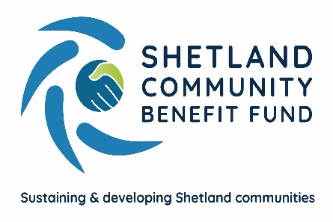
SCBF Directors Meeting

10th August 2022 at 1800

Market House Conference Room

Present

Chris Bunyan, Aileen Brown, John Parry, David Cooper, John Dally, Kenny Pottinger, Angela Sutherland, James Garrick and Neville Martin.

In Attendance

Eleanor Gear, Administration Officer

1. Apologies

Robin Black, Colin Clark, Jim Milne, Jim Anderson, Karen Hannay and Alistair Laurenson

2. New declarations of interests

None.

3. New Directors/Observers

None.

4. Minutes of 10th July 2022

Proposed by John Parry, seconded by Aileen Brown. Agreed.

Matters Arising and not covered by the agenda

None

5. Audit and Governance group

Nothing to report.
6. Administration

Nothing to report.
7. Financial Report

(a) Report on 2022-23 income and expenditure - circulated

The main change on the income and expenditure report is the movement of funds between the savings accounts and business current account. Funds are moved as required to meet SCBF’s financial obligations. Finance report noted.

8. Legal and Accountancy Advice

There was a verbal report from CB on the legal and accountancy services and the need for SCBF to ensure it received value for money and the best advice for the best cost. While directors were confident that they currently received an excellent service from professional advisers, it was agreed to carry out an informal review of these services.

9. Viking Energy

Lindsay Dougan (SSE Renewables) will be in Shetland next month and will attend the September meeting.

10. Business Plan Sub-Group

CB provided a verbal update and advised that SCBF are still waiting for an updated cost on the postal survey from ibp. At the moment the consultation is approximately one month behind schedule, but this isn’t a concern due to the timeframe available for the work. There is a meeting between ibp and the Business Plan sub-group on Tuesday 16th August where it is hoped that the initial publicity on the consultation launch will be decided. It is at this point that SCBF will take a step back and ibp will begin consultations with the wider public, in groups, individually, face-to-face and virtually.

11. AGS

(a) Email to community councils (AGS Review) – circulated

The drafted email explains any changes to the AGS and the reasons for them following the AGS review. No additional comments were made and EG will send the email to community council clerks.

(b) Report on applications received – circulated

Report noted.

(c) AGS Review – draft documents circulated

Documents circulated for information purposes. All changes were agreed during the directors meeting in July. Amended documents will be effective from 1st September 2022.

12. Shetland Aerogenerators Community Benefit Fund

Nothing to report. Bells Brae Parent Council have been sent an evaluation to complete but SCBF have not yet received it.

13. Other commercial renewable energy scheme

(a) SIC Energy Development Principles and Meeting Notes - circulated

CB, Colin Clark and John Parry had a meeting with SIC/ORION/Carbon Net Zero representatives at which SCBF made a positive case for being the channel for community benefit. Another meeting is planned which will involve SIC politicians. Angela Sutherland mentioned that the notes circulated speaks about drawing up an agreement and this would be a good way to formally agree roles and set out SCBFs independence.

Nothing to report on any of the other schemes.

14. Any other business

Date of next meeting – 14th September 2022 at 1800

Meeting closed at 18:42 with nothing further to discuss.

