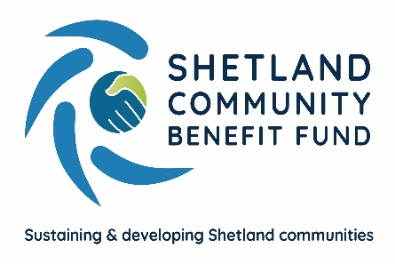
SCBF Directors Meeting

9th November 2022 at 1800

Market House Conference Room

Present

Chris Bunyan, Aileen Brown, Alistair Laurenson, Jim Anderson, Alistair Christie-Henry, Angela Sutherland, John Parry, John Dally, James Garrick, Colin Clark, David Cooper, James Garrick, Jamie Macbeath and Neville Martin.

In Attendance

Eleanor Gear, Administration Officer

1. Apologies

Jim Milne

2. New declarations of interests

None.

3. New Directors/Observers

None.

4. Minutes of 12th October 2022

Proposed by Alistair Christie-Henry, seconded by Jim Anderson. Agreed.

Matters Arising and not covered by the agenda
- SCBF Minutes

The format of the SCBF monthly meeting minutes was discussed and it was agreed that when there was an item involving a third party, particularly regarding any discussion or negotiation concerning a community benefit agreement, and including any legal or financial advice, that directors should consider whether the discussion should be confidential and omitted from the public minutes.

5. Audit and Governance group

Aileen Brown has drafted a list of questions for a mini audit and distributed them to the Audit and Governance group for comment.
6. Administration

The Administration Officers pay review is hoped to be complete by the end of the year. This will be backdated.

7. Financial Report

(a) Report on 2022-23 income and expenditure - circulated

Finance report noted.

8. Legal and Accountancy Advice

There has been no response to the legal and accountancy letters sent by SCBF.

9. Viking Energy

CB raised a point to note – as we move into early next year we will need to begin making important decisions and start thinking about how and who will make decisions. CB anticipates that an initial discussion with SSE on the MoA is likely to take place in the first quarter of next year.

10. Business Plan Sub-Group

The community consultation has begun. For information, an email was circulated amongst directors which originated for VAS (sent to them by IBP), inviting third sector community groups to become involved in the consultation. IBP will be in Shetland next week to host some of these sessions. The Business Plan Sub-group meet with IBP on the last Tuesday of each month.

11. AGS

(a) Application Summary Report – circulated

Report noted.

(b) AGS Procedures – Community council no quorate

CB referred to an earlier discussion held during the August meeting in 2021 where the action of SCBF would be to urge community councils to find an alternative way to make decisions, such as email.

(c) Community councils Zoom meeting

It was agreed to offer a Zoom meeting to community councillors and clerks in January to discuss the AGS and any queries they may have.

After the community council elections on the 24th November, EG will email the two community councils who do not have a director sitting on the board and the two which do not participate in making decisions on AGS applications to ask if they would like to reconsider.

12. Shetland Aerogenerators Community Benefit Fund

Nothing to Report.

13. Other commercial renewable energy scheme

The Other Schemes Sub-Group reported on various discussions that had been held with third parties concerning possible onshore and offshore developments. There report was noted.

14. Any other business

Nothing to discuss.

Date of next meeting – 14th December 2022 at 1800. This meeting will be held remotely via Zoom.

Meeting closed at 1855 with nothing further to discuss.

