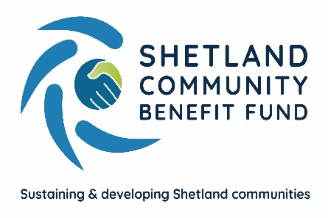

SCBF– Complaints Procedure

Purpose and Scope
The purpose of the complaints procedure is to ensure that applicants have an easily accessible and straightforward means of raising a complaint to Shetland Community Benefit Fund, and which offers prompt action and speedy resolution of complaints.
Informal Complaint
An informal complaint is an initial approach outlining dissatisfaction with an aspect of SCBF’s service or actions. This would usually be in person, by telephone or may also be in writing.
The administration officer is likely to deal with such initial informal complaints and attempt to resolve concerns in the first instance. These types of complaints are usually a request for action, information or reporting a problem. The administration officer will provide information or arrange action to satisfy the customer but where necessary would escalate to the SCBF committee.
At this stage, the emphasis is on resolving the complaint wherever possible.
Formal Complaint
A formal complaint usually arises when the complainant is unhappy with the outcome of SCBF’s response at an informal level or when the complaint is of a severe nature in the first instance leading directly to the formal stage.
All formal complaints must be made in writing to the audit sub-committee of SCBF, who will acknowledge receipt of the complaint within 5 working days. A full written response to the complaint would normally be made within 15 working days with any delay and explanation informed in writing.
Further Stages
It is hoped the vast majority of complaints are resolved within these two stages, however, if the complainant is still not satisfied, they may appeal the outcome within 14 days by writing to the Chair of SCBF. The Chair will then nominate three directors of SCBF to investigate the appeal. A response will be sent within 15 working days. Their decision will be final.
Grant application appeals are covered separately under the appeals process.

Document issue date – February 2021
Document review date – February 2024

