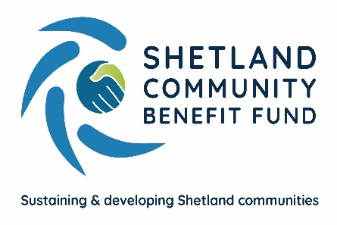
SCBF Equality, Diversity and
Inclusion Policy

Purpose and Scope of Policy
SCBF is committed to ensuring equality, diversity and inclusion among our employees, volunteers, and individuals or any organisation who is awarded a grant under the Viking Community Fund's Advanced Grant Scheme or any other support programme managed by SCBF. We are committed to preventing unlawful discrimination on the grounds of gender, age, disability, marital status, sexual orientation, religion and race in the provision of all services undertaken.
Any individual, business or other organisation undertaking work on behalf of SCBF and those in receipt of a grant, are also expected to abide by this policy.
The policy’s purpose is to:
- Provide equality, fairness and respect for all in our employment, whether voluntary, temporary, part-time or full-time and for applicants for financial support and users of any project which is supported by grant aid from SCBF.
- Not unlawfully discriminate because of the Equality Act 2010 protected characteristics of age, disability, gender reassignment, marriage and civil partnership, pregnancy and maternity, race (including colour, nationality, and ethnic or national origin), religion or belief, sex and sexual orientation.
- Oppose and avoid all forms of unlawful discrimination. This includes in pay and benefits, terms and conditions of employment, dealing with grievances and discipline, dismissal, redundancy, leave for parents, requests for flexible working, and selection for employment, promotion, training or other developmental opportunities.
SCBF commits to:
- Encourage equality, diversity and inclusion in all its work and by all successful applicants for grant awards.
- Ensure any business, trust, organisation or individual either working for, or on behalf of, or receiving support or assistance of any kind agrees to – promote equality and inclusion and does not incite or attempt to incite others to practice direct or indirect discrimination.
- Create and support working environments free of bullying, harassment, victimisation and unlawful discrimination, promoting dignity and respect for all, and where individual differences and the contributions of all staff, volunteers and users of projects that are supported by SCBF are recognised and valued.
- All staff should understand they, as well as their employer, can be held liable for acts of bullying, harassment, victimisation and unlawful discrimination, in the course of their employment, against fellow employees, service users and the public
- Take seriously complaints of bullying, harassment, victimisation and unlawful discrimination by fellow employees, visitors, the public and any others in the course of the organisation’s work activities.
Protecting Vulnerable Groups (PVG) Scheme
We will request a Protection of Vulnerable Groups (PVG) Scheme Membership record where it is necessary and relevant to the position or application for support. We will make this clear in the application / enrolment form.
No individual fully listed as unsuitable to work with children under the terms of the Protection of Vulnerable Groups (Scotland) Act 2007 will be appointed or given assistance or support.

Document review and monitoring
SCBF recognise that promoting equality, diversity and inclusion is an ongoing commitment and therefore this policy will be reviewed annually as a minimum. We will monitor the success and impact of this policy to ensure that SCBF practices and promotes equal opportunities.
Raising a complaint
Anyone who feels they have been discriminated against by either SCBF or any other organisation or individual it is working with should raise the matter with the administration officer. If they are dissatisfied with the outcome, the person or organisation should raise the matter, in writing, as a formal grievance under the SCBF complaints procedure.

Details of the organisation’s complaints policy can be found at www.scbf.org.uk

Document issue date – February 2021
Document review date – February 2024

