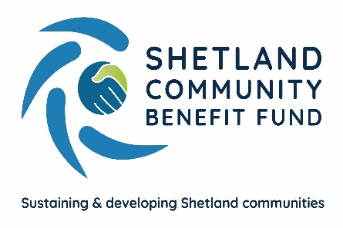
Half a million in grants from Viking Community Fund

30th October 2022
Over £500,000 has been awarded from the Viking Community Fund in the past 20 months to over 100 projects throughout the islands by Shetland Community Benefit Fund which runs the grant scheme during construction of the wind farm.
Projects from Fair Isle to Unst and Foula to Skerries have been supported with grants ranging from as little as £200 to the RVS to provide a social activity to £53,000 for insulating a recreation room.
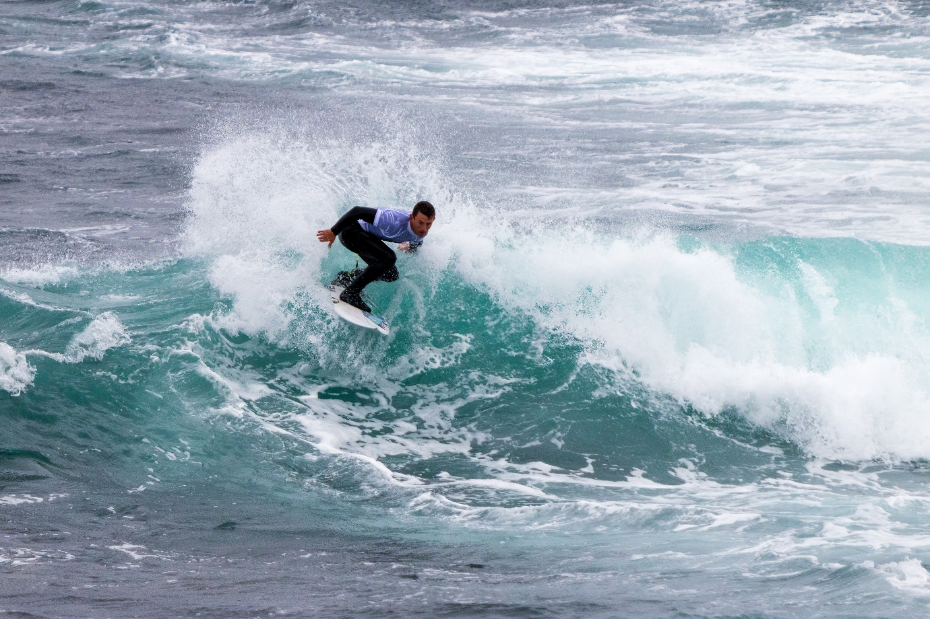
Figure 1 The Scottish Surfing Federation received a Viking Community Fund AGS grant of £1,625 towards the recent Gathering of the Clans surfing event held in Sumburgh.
The Advanced Grant Scheme sees £50,000 a year going to the four community council areas where there will be Viking turbines and £10,000 to the other 14 community council areas in the islands. All the application paperwork is carried out by SCBF, with community councils deciding whether or not to support a project. While most applications concern local initiatives, Shetland-wide organisation also apply to a number of areas asking for support. Details of all approved grants are published on the SCBF website.
Nesting and Lunnasting has seen the most grant aid – nearly £114,000 going to 13 projects including the Nesting Toddlers being awarded £500 to establish a new toddler group and Lunnasting Public Hall getting £53,000. In Sandsting and Aithsting 17 projects have received grant including over £44,500 to the Skeld Hall to replace its wind turbine and associated works, and £7,670 to Aith Junior High School Parent Council for 26 iPad and covers.
The fire alarm system in the Voxter Centre was renewed thanks to a £7,409 Grant approved by Delting Community Council – part of over £70,000 in grants approved by community councillors.
The Tingwall, Whiteness and Weisdale Community Council has approved grants totalling nearly £22,000 but, like a number of other areas, is not using all its allocated funds because of future projects known to be in the pipeline.
SCBF chair, Chris Bunyan, said it was rewarding to see so many worthwhile projects being supported. “Often it is small grants that can make a really big difference for a local community. We also know there are a number of larger projects being developed around the islands and look forward to getting these applications. We would encourage anyone or any group with an idea to approach us to see how the Viking Community Fund might be able to help.”
“We would particularly encourage organisations and groups, and indeed community councils themselves, to come forward with initiatives to help people who might be struggling with inflation and the increased cost of living.”

ENDS
Note: All approved grants are published on the SCBF website at https://scbf.org.uk/projects/

For further information contact Chris Bunyan 07880590331 or 01595820336

