Projects helped by Viking community funds

Local projects with a total value of nearly £3m have been supported by the Viking Community Fund since it started in 2021. Grant aid totalling nearly £700,000 has been approved for over 300 applications to the fund, which is run by Shetland Community Benefit Fund.
The grant aid is used either to provide 100% funding for smaller projects, or to help secure funding from other sources.
A large range of projects have seen grants approved in the past few months from around the islands – Sandsting and Aithsting has seen two of the largest grants with £32,700 for improvements to the Aith marina and over £22,000 for upgrading the village hall’s toilets and fire doors.
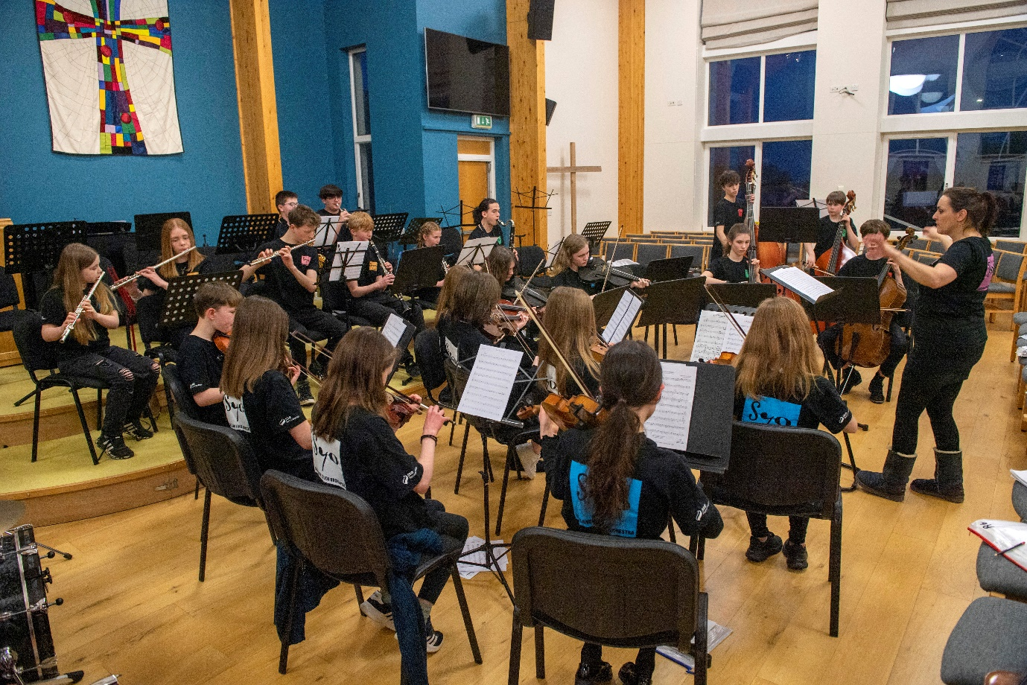
Shetland Youth Orchestra received a £4,509 grant towards equipment and its summer school.
Among the other larger grants is over £10,400 to Shetland Amenity Trust’s tree nursery at the Staney Hill. Solene Giraudeau-Potel from the trust’s tree nursery project said: “The funding from the Shetland Community Benefit has enabled us to complete our funding package to support the expansion of Shetland’s only native tree nursery. The expansion of the unit is essential to ensure the protection and enhancement of our native tree stock and to support growing demand from communities, businesses and landowners for trees to support woodland creation.”
Among the smaller grants the Ollaberry Youth Club, the Southend’s Under 5s and the Kiddy club in Lerwick each got £500 to support their work, Christmas events for young and old were supported as well as various sporting groups – the Delting Dolphins and South Mainland Swimming Club each received a £500 grant.
SCBF chair, Chris Bunyan, said it was very encouraging to see the range of activities supported by the fund and the fact every area was benefitting. “However, I’d like to stress that the fund is open to projects to help local communities tackle the cost of living crisis. We would encourage groups and community councils to come forward with any ideas – the more imaginative the better.”
Full details of the SCBF grant scheme and all the projects it has supported are available at www.scbf.org.uk
ENDS

For more information contact Chris Bunyan on 01595820336 or 07880590331

