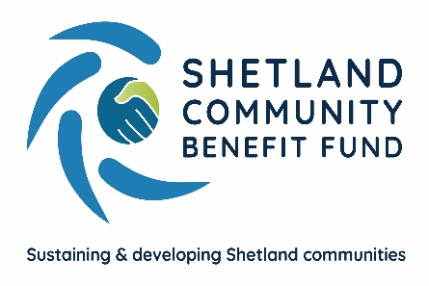
SCBF Recognising your grant award - Publicity Guidance

Introduction
It is a condition of your grant that you publicly acknowledge the funding from Viking Community Fund’s Advance Grant Scheme. This document gives guidance on the different methods of recognition and what these platforms can do for you as an organisation or group. The level of recognition expected will be in line with the level of the award.
The Viking Energy and Shetland Community Benefit logo’s are available by contacting the SCBF Administration Officer – admin@scbf.org.uk
Press Releases, Media and Public Relations
Media relations can help your group by raising its public profile, increase the understanding of your organisation and the work you are doing and create a positive profile of your organisation through a good news story.
Media releases should ideally be no longer than 400-500 words avoiding long and complicated sentences. It should cover,
- Who you are, who your news affects and who is benefiting?
- What is new?
- Why is this important?
- Where is this happening?
- When is it happening? Is this significant?
- How did this come about?
Background information about your organisation should be covered in a ‘note to the editor’.
You should acknowledge your grant in the text of your press release and add the Viking Energy and SCBF logos in the footer. SCBF would also be happy to provide a quote if requested.
Online and Social Media
Facebook and Twitter are two online platforms often used to promote and highlight what groups and organisations are up to. You should keep posts/tweets brief and to the point, long reads tend to put people off and they skip past without reading.
When promoting a project which has received a grant, you should acknowledge in the text where the grant has come from and feature the Viking Energy and SCBF logos.
Link it to us on Facebook ‘Shetland Community Benefit Fund’ or with Viking Wind Farm on Twitter (@sserenewables) and LinkedIn (SSE Renewables). This will enable us to share your stories with our wide network of followers on our social media channels.
Please ensure you comply with you GDPR principles when using social media e.g. do not share any personal details and ensure you have consent from anyone used in any photography to use their image on social media.
Publications and Promotional Material
Leaflets, fliers and posters can be used to target specific audiences. Whilst online platforms may seem to be the ‘norm’, there are individuals who may be missed and it doesn’t have the capacity to target a particular local area. Notice boards in local shops displaying posters make your organisation easily visible in that area. Leaflets provide something tangible which can be viewed and taken home for further consideration. This is particularly helpful if you are a new group or organisation trying to establish yourself and raise awareness of what you do.
You should acknowledge your grant in the text of your leaflet, flier or poster and feature the Viking Energy and SCBF logos.
Events
Holding an event allows you to reach a targeted audience and depending on the format, allows you to interact directly and on a personal level when informing people about what your group or organisation does. It may also help you to make useful connections which can be used when establishing or growing your group/organisation.
If you are holding an event that has been funded by a grant from the Viking Community Funds Advance Grant Scheme, the funding should be acknowledged at the event and on promotional materials. The Viking Energy and SCBF logos should be displayed on banners, signage, invitations, programmes, brochures or any other materials.
Signs
Where a grant from the Viking Community Funds Advance Grant Scheme has been used on a large project where a signage is to be erected on completion, the Viking Energy and SCBF logos should be displayed on the plaque/signage alongside any other funders logo. As a rule, such signage would be displayed at the customer/public entrance to the building.
Note
These guidelines are not intended to be interpreted as a rigid set of rules, SCBF on behalf of the Viking Community Fund are willing to be flexible where the recipient of a grant can evidence that it would be difficult or unduly expensive to implement a particular suggestion. For example, you may have a quantity of promotional materials which need to be used prior to printing more containing the new logo in recognition of the grant you have received.

If you have any queries regarding this policy or require further guidance, please contact Eleanor Gear, Administration Officer – admin@scbf.org.uk

Document issue date – March 2021
Document review date – April 2024

