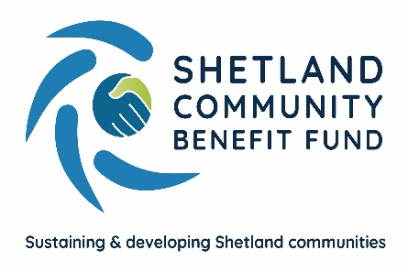
SCBF Directors Meeting

13th September 2023 at 1800

Market House Conference Room

Present

John Dally (Vice-Chair), Alistair Laurenson, David Cooper, John Parry, Jamie Macbeath, Jim Anderson, Colin Clark, Aileen Brown and James Garrick.

In Attendance

Lindsay Dougan, SSE Senior Community Investment Manager
Eleanor Gear, Administration Officer
Ryan Arthur, Skerries Observer

1. Apologies

Chris Bunyan and Alistair Christie-Henry.

2. New declarations of interests

None

3. New Directors/Observers

Ryan Arthur attended as an observer for Skerries. He was welcomed by John Dally.

4. Minutes of 9th August 2023

Proposed by John Parry, seconded by David Cooper. Agreed.

Matters Arising and not covered by the agenda

None

5. Audit and Governance group

The group met recently and discussed various issues. They would like to view the AGS funding spreadsheet and are aware of additional areas for audit and governance when the new MoA comes into effect.
6. Administration

(a) SCBF Banking – Report circulated

Directors agreed to remain with the current provider. Report noted.

7. Financial Report

(a) Report on 2023-24 income and expenditure - circulated

Report noted.

8. Legal and Accountancy Advice

Nothing to report.

9. Viking Energy

(a) Minute of Agreement

There was a general discussion regarding the proposed Minute of Agreement for the main fund.

(b) Investment Group Report

A report from the group will be circulated when available.

10. Business Plan Sub-Group

(a) Consultation Update – Report circulated

The Business Plan Sub-Group reported on their progress.

11. AGS

(a) Application Summary Report – circulated

Colin Clark asked why there is a significant difference between the total value of applications and the value of approved funding. Eleanor explained that the difference of just over £200,000 is the sum of all the applications which have not received funding or received partial funding. A high proportion of this figure relates to Shetland-wide applications. Jim Anderson asked how long an applicant has to spend their grant. Eleanor advised that they have 12 months from the date on their offer letter, however, if a reasonable project delay is advised, this timeframe can be extended.

Report Noted.

12. Shetland Aerogenerators Community Benefit Fund

No further update.

13. Other commercial renewable energy scheme

The sub-group continues to maintain contact regarding proposed local developments.

14. Any other business

Lindsay Dougan once again thanked SCBF directors for all their time as volunteers, for their support setting up this scheme and for SCBFs strong foundations going forward.

Date of next meeting – 11th October 2023 at 1800

Meeting closed at 1845 with nothing further to discuss.

