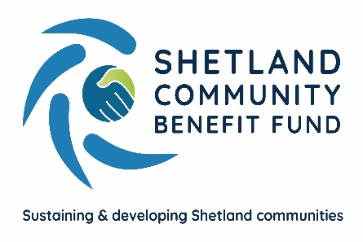
SCBF Directors Meeting

8th November 2023 at 1800

Market House Conference Room

Present

Chris Bunyan, Alistair Christie-Henry, John Dally, Alistair Laurenson, John Parry, Jamie Macbeath, Neville Martin, James Garrick, Colin Clark, Jim Anderson, Aileen Brown, David Cooper and Kenny Pottinger

In Attendance

Ryan Arthur, Skerries Observer
Eleanor Gear, Administration Officer

1. Apologies

None

2. New declarations of interests

None

3. New Directors/Observers

None

4. Minutes of 11th October 2023

Proposed by John Parry, seconded by Alistair Laurenson. Agreed.

Matters Arising and not covered by the agenda

None

5. Audit and Governance group

The group had nothing to report. CB appealed to the members of the Audit and Governance group to meet. He added that as SCBF move towards the main fund, the MoA and Business Plan there is an increasing importance on their work.
6. Administration

(a) VAS Office

SCBF are awaiting the formal contract from VAS. Eleanor will organise furniture and IT once the contract is signed.

7. Financial Report

(a) Report on 2023-24 income and expenditure - circulated

Colin Clark asked if the 2023/24 AGS funds had been received by SCBF. Eleanor confirmed that they had been requested but had not reached our account yet, however, they were due soon.

Report noted.

(b) Investment Policy and Investment Decisions

SCBF will need an investment policy detailing how they will approach this issue. A subgroup has held meetings with several financial advisors to explore available options. An investment policy and a report from these meetings are both still being drafted.

8. Legal and Accountancy Advice

Legal and accountancy advice has been sought on the draft MoA. The initial invoices for this advice have been paid and it is hoped that SCBF will only need to seek advice one more time before the final draft is agreed.

9. Viking Energy

(a) Minute of Agreement

There was a general discussion regarding the proposed Minute of Agreement for the main fund. Chris reported that SCBF have sent a detailed response to SSE on the current draft.

10. Business Plan Sub-Group

(a) Consultation launch and next steps

The work of the Business Plan subgroup and Fund Management group has increasingly overlapped, and they have now combined and meet collectively. During the October meeting, directors adopted the priorities for the fund and a press release was issued to this effect on Tuesday 7th November. The next steps are for the group and IBP to start working together on objectives and measures for these priorities. Some initial meetings have already been held with stakeholders in a few of these areas.

(b) Website

The meeting heard from the Website working group that progress was being made in finalising the SCBF requirements from its new website and the likely costs.

(c) Staffing and Decision Making

The meeting considered a report on the likely future staffing needs for SCBF as we moved toward the main funding and it was agreed to consider the need for any new posts. The report also proposed that directors should delegate more grant decision-making to staff, overseed by the officers, with monthly reports to meetings. However, directors would still make the significant decisions regarding any major strategic funding projects, based on reports from staff. This was agreed by directors.

11. AGS

(a) Application Summary Report – circulated

Report Noted.

12. Shetland Aerogenerators Community Benefit Fund

No further update.

13. Other commercial renewable energy scheme

The sub-group continues to maintain contact regarding proposed local developments.

14. Any other business

David Cooper said he was alarmed by the news of UHI cutbacks and considering our recently published priorities of retaining young people could SCBF be proactive and offer any assistance in the short term. Was there an imaginative way we could help? CB advised that the current scheme is not designed to provide that type of help and any application would need to go to community councils as they do now. He assured David that Eleanor has been speaking to stakeholders regarding bursaries and apprenticeships for the main fund. There are opportunities where the main fund could get involved and it is an area being looked at. However, it would not be possible to help under the current scheme.

Date of next meeting – 13th December 2023 at 1800

Meeting closed at 1907 with nothing further to discuss.

