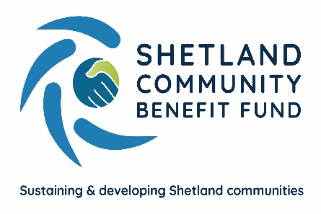
SCBF Directors Meeting

13th December 2023 at 1800

Market House Conference Room

Present

Chris Bunyan, John Dally, John Parry, Colin Clark, Aileen Brown and David Cooper

In Attendance

Ryan Arthur, Skerries Observer
Eleanor Gear, Administration Officer

1. Apologies

Alistair Christie-Henry, Alistair Laurenson, Angela Sutherland and Karen Hannay.

2. New declarations of interests

None

3. New Directors/Observers

None

4. Minutes of 8th November 2023

Proposed by John Dally, seconded by John Parry. Agreed.

Matters Arising and not covered by the agenda

None

5. Audit and Governance group

Two members of the audit and governance group met recently and a report from their meeting was circulated. Once the SCBF office is up and running they will arrange a further meeting to audit applications. CB reminded them that the work of the group will increase as SCBF move towards and begin operating the main Viking fund.
6. Administration

The lease for the office in Market House has been signed and Eleanor has ordered office furniture which is due to arrive in the New Year. Two sets of IT (laptops and accessories) are also in place.

7. Financial Report

(a) Report on 2023-24 income and expenditure - circulated

Eleanor advised that the 2023/24 Viking community funds are now in SCBFs account and for financial protection have been spread across our savings and current account.

Report noted.

(b) Investment Policy and Investment Decisions

A draft investment policy was circulated to directors. The first part of the report details how SCBF will manage the fund and part two concerns ethical decisions on where SCBF would invest. David Cooper asked why we would have a financial adviser and a fund manager as that would be two sets of (expensive) costs. Aileen Brown advised that these roles are usually separate and only required if SCBF do decide to make investments. Chris added that our policy and what we intend to do will need to be approved by SSE. Report noted.

8. Legal and Accountancy Advice

Nothing to report.

9. Viking Energy

(a) Minute of Agreement

There was a general discussion regarding the proposed Minute of Agreement for the main fund. Chris reported that SCBF have a meeting scheduled with SSE next week.

10. Business Plan Sub-Group

(a) Consultation launch and next steps

IBP and the subgroup met at the end of November where it was agreed that IBP would add some detail to the business plan with the aim of having a first draft available to the group by the end of December. IBP will also be scheduling and holding meetings with stakeholders with a view to drafting objectives for the identified priorities.

(b) Website

The meeting heard from the Website working group that progress was being made in finalising the SCBF requirements for its new website and the likely costs.

(c) Staffing

An advert for an Administration Officer is running in the local paper and online with a closing date of the 22nd of December. Interviews will take place in the New Year.

11. AGS

(a) Application Summary Report – circulated

Report Noted.

12. Shetland Aerogenerators Community Benefit Fund

No further update.

13. Other commercial renewable energy scheme

The sub-group continues to maintain contact regarding proposed local developments.

14. Any other business

CB thanked directors for their work and support over the past year and wished everyone a peaceful Christmas and all the best for the New Year.

Date of next meeting – 10th January 2024 at 1800

Meeting closed at 1828 with nothing further to discuss.

