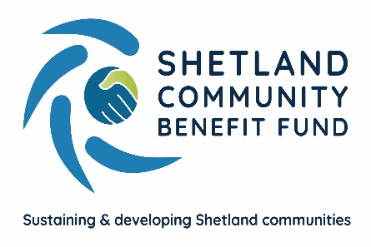
SCBF Directors Meeting

10th January 2024 at 1800

Market House Conference Room

Present

Chris Bunyan, John Dally, John Parry, Colin Clark, Aileen Brown, Alistair Christie-Henry, Alistair Laurenson, Jim Anderson, James Garrick, Jamie Macbeath, Neville Martin and David Cooper

In Attendance

Eleanor Gear, Administration Officer

1. Apologies

Karen Hannay and Ryan Arthur (Skerries Observer)

2. New declarations of interests

None

3. New Directors/Observers

None

4. Minutes of 13th December 2023

Proposed by Aileen Brown, seconded by Colin Clark. Agreed.

Matters Arising and not covered by the agenda

None

5. Audit and Governance group

Nothing to report. A meeting between the Administration Officer and Audit and Governance group will be scheduled in the next few weeks.
6. Administration

Most of the furniture for the office has now arrived and is in situ. Desk chairs are due by the end of the week.

7. Financial Report

(a) Report on 2023-24 income and expenditure - circulated

Colin Clark asked if the financial reporting would have a more formal format when we move into the main fund. Whilst this hasn’t been discussed in detail, it is anticipated that it will be.

Report noted.

(b) Investment Policy and Investment Decisions

A report drafted by Aileen Brown on the cash management options was circulated prior to the meeting. Report noted.

8. Legal and Accountancy Advice

Nothing to report.

9. Viking Energy

(a) Minute of Agreement

There was a general discussion regarding the proposed Minute of Agreement for the main fund. Chris reported that SCBF have a meeting scheduled with SSE next week.

10. Business Plan Sub-Group

(a) Consultation launch and next steps

IBP are preparing an initial full first draft of the Business plan and have scheduled and held various stakeholder meetings to explore the priorities identified in the consultation. Several members of the Business Plan sub-group have also been involved in these meetings and advised that there have been some interesting ideas coming from them.

(b) Website

The meeting heard from the Website working group that progress was being made in finalising the SCBF requirements for its new website and the likely costs.

(c) Staffing

Interviews for an Administration Officer are due to take place on Tuesday 23rd January and it is hoped that SCBF will have someone in place mid/end February.

11. AGS

(a) Application Summary Report – circulated

Report Noted.

12. Shetland Aerogenerators Community Benefit Fund

No further update.

13. Other commercial renewable energy scheme

The sub-group continues to maintain contact regarding proposed local developments.

14. Any other business

No other business.

Date of next meeting – 14th February 2024 at 1800

Meeting closed at 1914 with nothing further to discuss.

