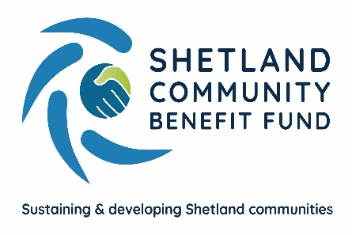
Shetland Community Benefit Fund Ltd
Market House
14 Market Street
Lerwick
Shetland
ZE1 0JP

Contract signed for major community consultation
Shetland Community Benefit Fund has taken the first important step towards a major Shetland-wide consultation to consider priorities for the £2.2m annual funds it will receive when the Viking Wind Farm begins operating.
After a successful tendering process, IBP Strategy and Research, based in Lanarkshire, have been appointed as the contractors for the consultation which will take two years to design and complete.
In preparing the community consultation, IBP will carry out an initial assessment of current issues in the islands including both face-to-face and virtual discussions with local statutory, industry and voluntary stakeholders.
The object of the consultation is to identify the strategic priorities for using the Viking Community Fund from summer 2024 when the wind farm is expected to begin using the interconnector cable. SCBF is able to use the £2.2m benefit funds, which are index-linked over the lifetime of the scheme, for grants, loans or investments in voluntary, charitable, social enterprise bodies as well as local businesses.
For the consultation IBP will organise local focus groups, on-line and telephone surveys and distribute copies of the consultation questionnaire throughout the islands. IBP will also make extensive use of the internet and social media to promote the consultation.
The initial responses to the consultation will be subject to a ‘testing phase’ to further develop the priorities raised in the consultation. All this work will result in an initial Business Plan being produced which will outline the objectives and priorities for SCBF. IBP will then consult the relevant local or national stakeholders to identify how the Viking Community Fund money can be best used to meet these priorities.
SCBF chair, Chris Bunyan, said the signing of the contract with IBP was a major step forward. “We can now begin to see the outcome of over 10 years work. Everyone in the community, whether an individual, business, social enterprise, charity, statutory body or voluntary group will be able to play their part in helping to decide how the community benefit money is spent.”
“The consultation will be conducted entirely independently by IBP without SCBF involvement except on any administrative issues.”
IBP director Eddy Graham said his team were looking forward to tackling this exciting project. “IBP have brought together a multi-disciplinary team to take forward the development of the SCBF Business Plan, with expertise in areas such as research, economic development, tourism, employability and anti-poverty strategies.
“Most importantly though, it will be the people and communities of Shetland that drive the content of the plan. We are looking forward to engaging extensively with communities across Shetland over the next couple of years, harnessing their ideas and identifying their priorities for the future. In this way, the plan will maximise the long-term benefits for all of Shetland’s residents.”
ENDS
17th January 2022
For further information please contact –
Chris Bunyan on 01595 820336 or 07880 590331
Eddy Graham on 07846 270104

Websites:
https://www.scbf.org.uk
https://ibp.eu.com/consultation-research/

