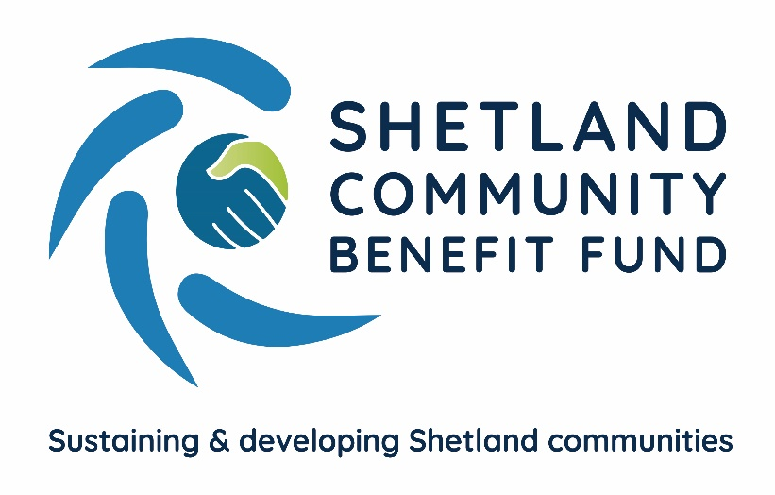
Community benefit fund awards more grants
Grants totalling over £200,000 have been approved by Shetland Community Benefit Fund since its grant scheme started in February. Over the six months the SCBF grants have helped support projects from throughout Shetland with a total value of nearly £1.4m.
Dogs Against Drugs has been awarded a total of £25,000 by most of the local community councils for its educational work and the Classic Car Show has received £4,600 towards it costs.
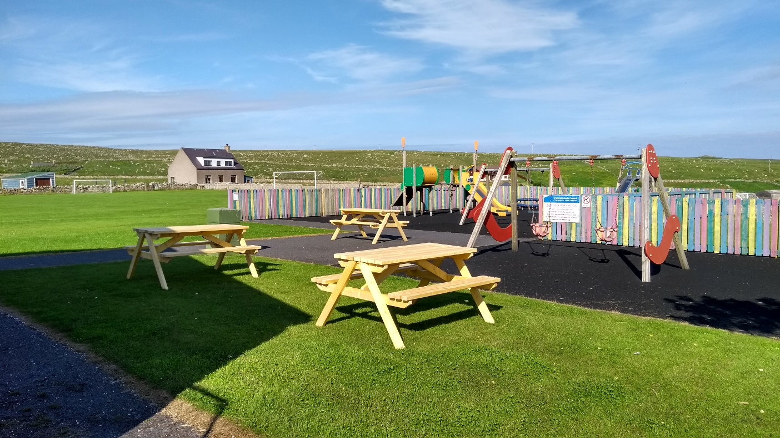
The South Mainland Community Association’s new picnic tables at Dunrossness Playing Field and Pavilion
The South Mainland Community Association got a grant of £500 towards their new picnic tables at the Dunrossness Playing Field and Pavilion while the South Mainland Amateur Swimming Club was awarded £1,500 towards its covid recovery wellbeing programme.
Among other grants awarded are £1,250 to the Hillswick Public Hall for new PA equipment, £1,500 for Sandwick youth and Community Centre to carry out a survey of their building.
Two grants were awarded to help look after local war memorials – The Quarff War Memorial will be repositioned with the help of a £2,380 grant towards the costs and the Burra War Memorial will see maintenance work carried out thanks to a £2,520 grant.
The community benefit fund’s grant scheme will remain open until 2024 and local community councils recently received an additional allocation of £340,000 for projects that they support.
ENDS
19th September 2021
For more information see www.scbf.org.uk/ags or contact SCBF chair, Chris Bunyan, on 01595 820 336 or SCBF administration officer, Eleanor Gear, on 07538 417 175

